# Using VMware on a MAC

Go to the following website and download the VMware view client for Mac: <https://my.vmware.com/web/vmware/details?downloadGroup=VIEWCRT_MAC_170&productId=266&rPId=3336>

Once downloaded, add this to your applications to install.

During the install it will ask you for a default connection server – **Type vdesk.cdu.edu.au**

When you start it up, it will look like this below.



**Double click on the ‘cloud’** (?)

This will prompt you to enter your username and password. **Enter your CDU credentials,** ensuring that the domain is CDU-STUDENTS



**Click continue**

When the window below pops up, **double click on the computer**



You should now be connected to the remote desktop!



To access Windows Explorer (to view drives and data), **Double click My Computer** on the desktop, and you should be able to see this:



To access your data from the server, you need to Map a Network Drive. In Windows Explorer, go to **Tools 🡪 Map Network drive**

For the drive, scroll down and **Select G:**

For the folder, **type \\student-cas\data$**

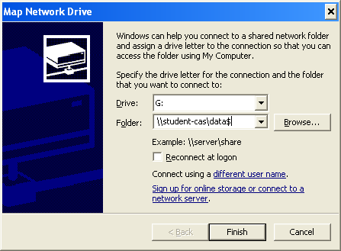

**Click Finish** and the following folders will appear.

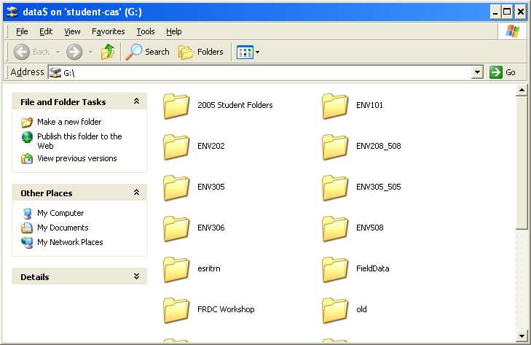

Data for this class is always held under RESOURCES\ENV202 and then within the individual practical folder. These are the same materials that were sent to you on a CD so you could use that instead if you like.

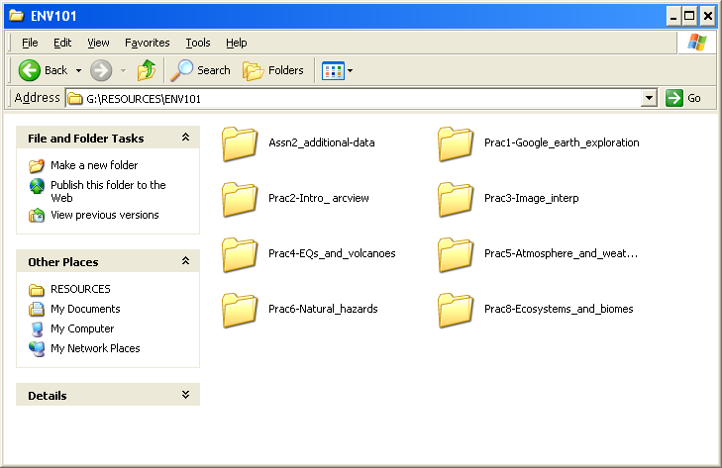

As stated in the individual practicals, it is important for you to copy the files onto your computer to use them for the class. To copy something using a Mac, use Command + C. Then paste it into the C:\temp folder (for example). To paste, use Command + V.

Note that using this remote access software, you do not need to install or license Liberty or ENVI (bonus!).

Let your lecturer know if you have any problems as a Mac user who is unfamiliar with Windows.