ENV202/502 INTRODUCTORY REMOTE SENSING

Practical Exercise 2 – Introduction to ENVI Image Processing and Analysis Software

Overview
This practical is designed as a brief introduction to the ENVI software interface. Students are expected to complete the exercises in order to provide the background knowledge required for subsequent practical exercises. Additional features of the software will be introduced and demonstrated in class, and students are encouraged to experiment with different operations and tools during practical sessions, and in their own time.

Learning Outcomes
After completing this practical, students should be familiar with some basic operations and tools within ENVI, including opening and viewing images, zooming, panning, and changing band display.

Preparation
You will first need to ensure that you have all the data required for this tutorial (as listed below).

Create a folder on your local hard drive where you have write access called ‘Prac2’. This will be referred to as your ‘working directory’

Copy today’s practical materials from G:\Resources\ENV202\ into your working directory

Required data
All data for this practical is available for internal students under:
G:\Resources\ENV202\

External students should have received these data on a CD in the mail.

L8_Darwin_240713_dps
L8_Darwin_240713_dps.hdr

This is a radiometrically and atmospherically calibrated Landsat 8, eight band multispectral image of Darwin and surroundings that was acquired on 24th July 2013. The *.hdr file is a ‘header’ file, and it contains information about the spectral bands, projection details etc. that ENVI uses to display your data. You can open (and edit) this file in a text editor (e.g. Notepad).

L8_Darwin_240713_TIR
L8_Darwin_240713_TIR.hdr

This is the temperature image using bands 10 and 11 from the same date and satellite as above. Units are uncorrected degrees Celsius.

Required software
You will need to have ENVI installed on your PC. If you are an external student and have not yet received the CD containing this software with installation instructions, please contact the lecturer immediately. This software is otherwise available in the GIS/RS computer lab in Building Purple 12.3.17.

Introduction to ENVI
ENVI is one of the many software packages dedicated to remote sensing image processing and analysis. It is the main software that will be used throughout over the course of ENV202/502 to conduct the practical exercises. It is an extremely complex and powerful piece of software, and thus it is not possible to teach all aspects of its use within an introductory remote sensing course. More advanced use of this and other image processing software is covered in ENV306/506 – Environmental monitoring and modelling, and through individual student projects (SID300 / SID301).

Starting ENVI

Go to Start → Programs → ENVI 5.0 → Tools → ENVI Classic + IDL

Note that it is important to use ENVI Classic, rather than opening the first ENVI link that you see, or the shortcut that is put on your desktop. The GUI is very different. ENVI Classic is a long-standing and more stable version of the software.

A single menu bar will open on your screen as below. This is the Main Menu

As you click on any of the main menu options, you will see further drop down menus and tools become available. We will explore some of these throughout the semester.

Setting Preferences
The first thing you should do before you start working with ENVI is to set the default path to your data directory. While this is not actually a necessary step, it will make opening and outputting data easier and faster, as ENVI will automatically look in the folder that you specify, rather than you having to navigate to this location each time.

On the main menu, Go to File → Preferences

Click on the Default Directories tab

Change the Data, Temp, and Output directories all to your working directory that you created in section 1.2. You can click the ‘choose’ button to navigate to the directory, or if you know the address, just type it in.
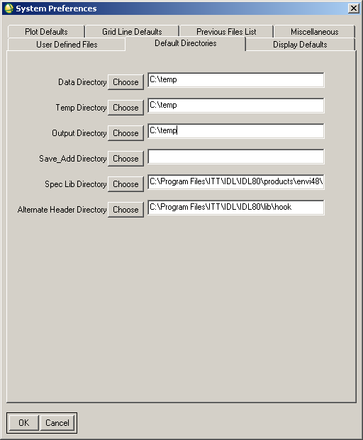

Click OK

When ENVI asks if you want to save the current preferences to a file, click Yes

Again, Navigate to your working directory after clicking the ‘Choose’ button, and save the ENVI.cfg file.

Click OK

Make sure that you are aware of the folder to which you are saving your output files as set in your preferences. If you are not aware of the default location that you set, you may think that you have ‘lost’ your data.

Opening and Viewing Image Data
Go to File → Open Image data

Note that ENVI will have defaulted to looking in your working directory for your input data as you have just set this to be the case in your preferences.

Select the file L8_Darwin_240713_dps → Open

A new window ‘Available Bands List’ will open. It is from this window that we are able to create a display for our images.

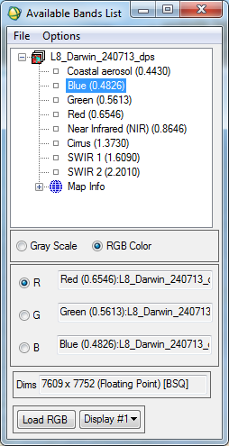

You will see that the file name is listed at the top, and underneath this are the names of the bands that comprise this multiband file. In brackets next to each of the band names is the centre wavelength (um) of that band.

At the bottom, you also have the ‘Map Info’ that you can expand to find out more about the spatial properties of your image.

Q1. What is the image pixel size? (1 point)

Q2. What projection and datum have been used for the image? You may wish to refer back to your notes from ENV101 about the importance of projections and datums (2 points)

Greyscale Displays
In the Available bands list, Click on Band 1 (Coastal – aerosol) to select it

Select the Grey Scale radio button → Load band

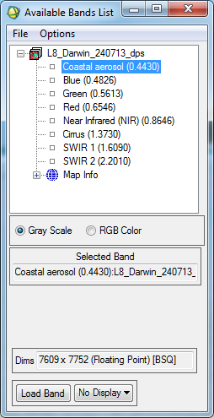

Three new windows will open. This is called the ‘Display Group’ and consists of the Scroll, Image, and Zoom windows. Each window will display band 1 (Coastal-aerosol) of this Landsat 8 image. Within the Scroll and Image windows, you will also see a red outlined box. This box within the Scroll window is showing what part of the image you will see in the Image window, and the box within the Image window is showing what you will see within the Zoom window. Within the Zoom window, you also have a ‘plus’ and ‘minus’ button on which you can click to further zoom in and out of your image.

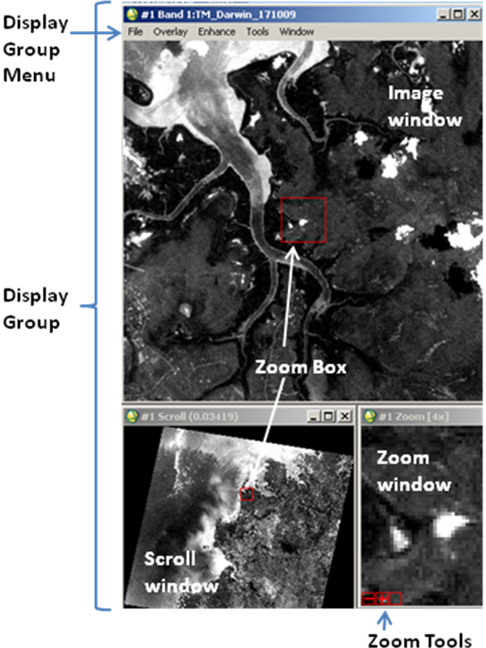

Click anywhere in the scroll window and the red box will move to that point and your views within the image and zoom windows will change accordingly.

Continue to navigate your way around the image to become familiar with how different features look in the Coastal-aerosol band.

In the Available Bands List window, Select Band 2 (Blue) → Load band (you can also just double click on the band name to load it automatically)

Your viewer windows will change to display the Landsat Blue band.

In the same way, change to each of your bands in turn to observe the differences in your image with respect to how features reflect and absorb different wavelengths of light.

Complete the following reference table specific to Landsat 8. The first one has been done for you. You may have to use the internet to look up the additional bands not used here.

Band Number | Band Centre Wavelength | Wavelength region represented
1 | 0.4430 | Coastal aerosol
2
3
4
5
6
7
8
9
10
11

Q3. Which band is the best for determining the outline of coasts and water bodies and why? (2 points)

Animating Your Image
Another way to view each of your bands in turn is to use an animation. This is also very useful for looking at time series data.

In the Display Group Menu bar, go to Tools → Animation

Ensure that all your bands are selected → OK

An animation will then start to scroll through your bands. You can experiment with the controls to speed up, slow down, pause, or reverse your animation.

Close the animation window when you have finished viewing your data.

Contrast Enhancements
Open the NIR band in your display group windows.

In the display group menu, go to Enhance → Interactive Stretching

In the new window that opens, go to Defaults → [Scroll] Linear

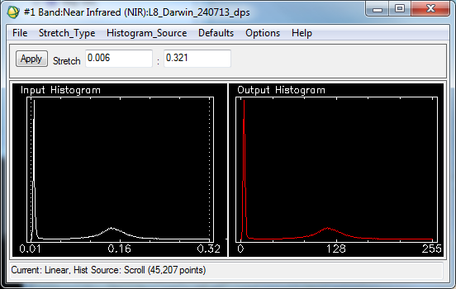

The histograms show the pixel values on the x-axis, and the number of pixels with that value on the y axis. The left hand image with the white curve shows the input data, while the right hand image with the red curve shows how the data will be displayed. The input pixel values can have a range of 0-1, while the output will have a computer display range of 0-255. As you have just set the stretch to [Scroll] linear, the curves look the same, as essentially no stretch has been applied. Your images in the display group may appear dull and lack contrast.

What you can see in the histogram is that there are two main modes (histogram peaks) – one where the pixel value is approx 0.01, and the other where the pixel value is approx 0.15. This means that lots of pixels within the image have these two values. By setting the stretch based on [Scroll], this means that the statistics are calculated using all pixels within the Scroll window (i.e. the entire image).

As part of the Input histogram, you should be able to see two vertical dotted lines. Use your mouse to click and drag the vertical lines to be positioned either side of the main pixel range as below. Click Apply and the output histogram will change, as will the display of your image.

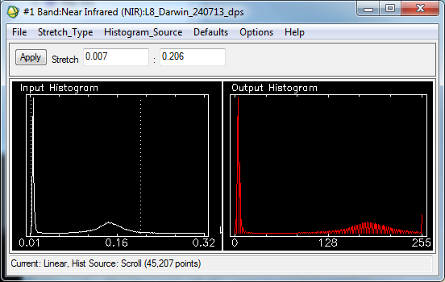

So what has happened? The Input histogram shows that there is a range of potential display values from 0 – 255 (this is 8 bit data), however the pixel values within the histogram really only fall within the range of approximately 0-140. This means that although there are potentially 256 values of grey that can be used to display your data, you are only using 143 of them. By performing this operation, you have forced these 143 values to be ‘stretched’ across the entire potential range of 256 values or shades of grey. This allows you to see much more contrast within your image, and is therefore called a ‘contrast enhancement’.

Experiment with different contrasts to see how your image display is affected. Note that you are not changing the data in any way, just the way in which it is displayed, so there is no way that you can ‘ruin’ your data.

Q4. What sorts of features are represented by the two main modes in the histogram? How is the display affected by applying the contrast to the range of only one of these modes? When and why might this be useful? (4 points)

Locating Features

Right click in one of your viewers → pixel locator

Type in the co-ordinates: 588525 E, 8488825 N → Apply

This is a really great example of the benefits of using different multispectral bands in your data analysis.

Q5. What is the feature that is located at and around this co-ordinate? (1 point)

Q6. What are the differences that you can see in the different bands? (2 points)

Thermal Imagery
In a new display group, open either band from L8_Darwin_240713_temp as a grey scale image. These are both thermal wavelengths and have been calibrated to degrees Celsius, though they have not been corrected for atmospheric effects.

Right click in your display group to make a geographic link between this thermal image, and one of your grey scale image displays of the same image.

Navigate your way around the thermal image, and observe how different features appear in this type of imagery. Here you will note that warm features are bright white, whereas cooler features are dark. Take note of how different land cover types retain and emit heat. This will be discussed further in lectures, and also on the field trip.

Re-visit the co-ordinate given in the previous section. How does it appear? In the next section you will be able to measure the actual temperature of this feature.

In the display group menu, go to Tools → Colour Mapping → ENVI colour tables.

Select ‘Rainbow’ and you will see that warmer features in the image will be coloured in ‘warm’ colours (i.e. red, orange, yellow), whereas cooler features will be coloured in blue and green hues. Experiment with other colour tables to find one that you like.

Querying Pixels

Double click your mouse in an open Image window containing your multiband image (i.e. NOT the thermal image to start with). An information box relating to your cursor location will open. Alternatively you can right click → cursor location / value.

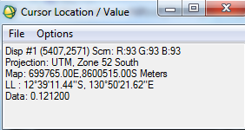

Move your cursor over your scroll, zoom, and image windows and observe the changing values, both spatially, and spectrally.

Use the same tool to query different pixels in the thermal image.

Q7. What is the temperature of the feature identified in section 4.4? (1 point)

Top Tips
- Don’t forget to set your preferences in ENVI when you start a session – this will make navigating to your input and output data a lot faster;
- Get comfortable with navigation using the three viewers of the display group;
- Don’t be scared to experiment, you can’t break anything!

