Chapter 6 Notes
ORIGINS AND HISTORY OF ETHERNET
  - Pre-1976 - Xerox was interested in finding a way to share their expensive printers between workstations
  - 1976 - Dr. Robert Metcalf (also David Boggs?) at PARC was tasked with creating a shared communications mechanism for this purpose. Dr. Metcalfe wrote a paper circa called "Ethernet Distributed Packet Switching for Local Computer Networks"
  - 1973 - Dr. Metcalfe aquired patent #4,063,220 for his Ethernet.
  - Ethernet was originally called the Alto Aloha Network protocol (later renamed Ethernet to indicate multi-platform compatibility)
  - 1979 - DEC and Intel joined forces with Xerox write a standard for ethernet. This was referred to as the DIX standard, and the publication was called the Ethernet Bluebook. Ethernet is defined as a 10 Mbps protocol running over coaxial cable and using CSMA/CD for transmission (thicknet).
  - 1983 - The IEEE released their version of the Ethernet standard in in the document IEEE 802.3. IEEE 802.3 was based largely on the DIX standard but with significant changes in frame format. However it was still backwards compatible with the DIX standard.
  - 1985 - IEEE 802.3a "Thinnet" (10 Mbps) - lower cost than thicknet.
  - 1987 - IEEE 802.3d "FOIRL" - Fibe Optic Inter-Repeater Link (10Mbps at 1000 meters)
  - 1990 - IEEE 802.3i - "10bT" - Category 3 Unshielded Twisted pair compatible cabling. Allowed use of existing telephony wiring.
  - 1993 - IEEE 802.3j - 10bF - 2000' range over fiber
  - 1995 - IEEE 802.3u - Defines the modern-day 100bT standard.
  - 1997 - IEEE 802.3x - Full duplex operation

The success of Ethernet is due to the following factors:
- Simplicity and ease of maintenance
- Ability to incorporate new technologies
- Reliability
- Low cost of installation and upgrade
in the early 1970s at the University of Hawaii. ( Alohanet) later formed the basis for the Ethernet access method known as CSMA/CD.
The first LAN in the world was the original version of Ethernet. Robert Metcalfe and his coworkers at Xerox designed it more than thirty years ago.
The first Ethernet standard was published in 1980 by a consortium of Digital Equipment Company, Intel, and Xerox (DIX).
released as an open standard.
The first products developed using the Ethernet standard were sold during the early 1980s.
Ethernet transmitted at up to 10 Mbps over thick coaxial cable up to a distance of two kilometers. This type of coaxial cable was referred to as thicknet and was about the width of a small finger.
In 1985, the Institute of Electrical and Electronics Engineers (IEEE) standards committee for Local and Metropolitan Networks published standards for LANs.
These standards start with the number 802. The standard for Ethernet is 802.3.
The IEEE wanted to make sure that its standards were compatible with the International Standards Organization (ISO)/OSI model.
some small modifications were made to the original Ethernet standard to address the needs of Layer 1 and the lower portion of Layer 2 of the OSI model for the 802.3 specification.
Essentially, Ethernet and IEEE 802.3 are the same standards.
The 10-Mbps bandwidth of Ethernet was more than enough for the slow personal computers (PCs) of the 1980s.
1990s PCs became much faster, file sizes increased, and data flow bottlenecks were occurring. Most were caused by the low availability of bandwidth.
In 1995, IEEE announced a standard for a 100-Mbps Ethernet.
This was followed by standards for gigabit per second (Gbps, 1 billion bits per second) Ethernet in 1998 and 1999.
All the standards are essentially compatible with the original Ethernet standard.
An Ethernet frame could leave an older coax 10-Mbps NIC in a PC, be placed onto a 10-Gbps Ethernet fiber link, and end up at a 100-Mbps NIC. As long as the packet stays on Ethernet networks it is not changed.
Ethernet is considered very scalable.
The bandwidth of the network could be increased many times without changing the underlying Ethernet technology.
The original Ethernet standard has been amended a number of times in order to manage new transmission media and higher transmission rates. These amendments provide standards for the emerging technologies and maintain compatibility between Ethernet variations.
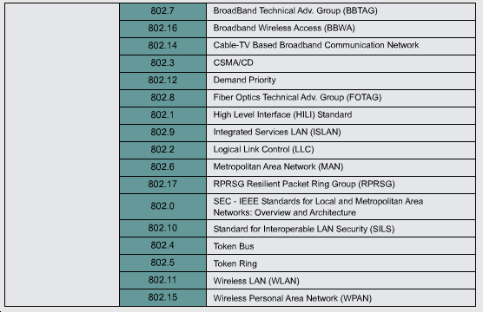

Ethernet is not one networking technology, but a family of networking technologies. When Ethernet needs to be expanded to add a new medium or capability, the IEEE issues a new supplement to the 802.3 standard. The new supplements are given a one or two letter designation such as 802.3u. An abbreviated description (called an identifier) is also assigned to the supplement.

The abbreviated description consists of:
- A number indicating the number of Mbps transmitted.
- The word base, indicating that baseband signaling is used.
- One or more letters of the alphabet indicating the type of medium used (F= fiber optical cable, T = copper unshielded twisted pair).

5 | 10mm 50 ohm coax (Thick coax)
2 | 5mm 50 ohm coax (Thin coax)
T | Unshielded Twisted Pair
F | Optic Fibre
TX | Unshielded Twisted Pair (4-pair)
SX | Short wavelength or multi-mode fibre
LX | Long wavelength or single-mode fibre
CX | Coaxial copper based media

Ethernet relies on baseband signaling, which uses the entire bandwidth of the transmission medium. An analog signal (carrier signal) is modulated by the data signal and the modulated carrier signal is transmitted.

The IEEE hopes to achieve the following:
- Supply the engineering information necessary to build devices that comply with Ethernet standards.
- Promote innovation by manufacturers.

Ethernet and the OSI

Ethernet operates in two areas of the OSI model, the lower half of the data link layer, known as the MAC sublayer and the physical layer.

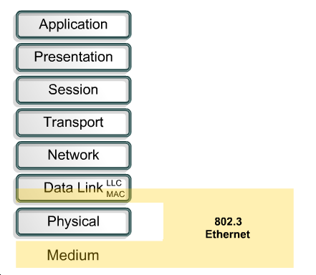

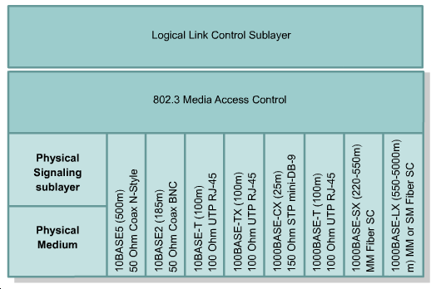

Data link sublayers contribute significantly to technology compatibility and computer communication. The MAC sublayer is concerned with the physical components that will be used to communicate the information. The Logical Link Control (LLC) sublayer remains relatively independent of the physical equipment that will be used for the communication process.

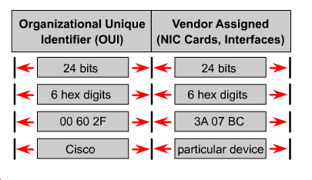

On an Ethernet network, when one device sends data it can open a communication pathway to the other device by using the destination MAC address. The source device attaches a header with the MAC address of the intended destination and sends data onto the network. As this data propagates along the network media the NIC in each device on the network checks to see if the MAC address matches the physical destination address carried by the data frame. If there is no match, the NIC discards the data frame. When the data reaches the destination node, the NIC makes a copy and passes the frame up the OSI layers. On an Ethernet network, all nodes must examine the MAC header even if the communicating nodes are side by side.
All devices that are connected to the Ethernet LAN have MAC addressed interfaces including workstations, printers, routers, and switches.
Layer 2 Framing

A transmission from one station on a shared media not only contains the application data that is required by the application layer on the receiving station, but a whole lot of other information added on by each layer of the OSI model. This information, transmitted through the media as an encoded bit-stream, would be meaningless to all other stations.

Framing enforces a fixed order and format onto the bit stream. Framing is the Layer 2 encapsulation process. A frame is the Layer 2 protocol data unit. A generic frame would need to include the following fields for the following reasons:

- Start frame field - need to know where the frame starts
- Address field – frame must have a destination
- Length / type field – needed so that end of frame can be known
- Data field – the payload of the frame
- Frame check sequence field – some method of checking for errors
Frame Check Sequence Number
Some function is performed on the bits that make up the frame. The result of the function is appended to the frame in the FCS field. The receiving station performs the same function on the frame and compares it’s result to the value in the FCS field. If the numbers differ, an error is assumed.
There are three primary ways to calculate the Frame Check Sequence number:
- Cyclic Redundancy Check (CRC) – performs calculations on the data.
- Two-dimensional parity – adds an 8th bit that makes an 8 bit sequence have an odd or even number of binary 1s.
- Internet checksum – adds the values of all of the data bits to arrive at a sum.
Frame Formats
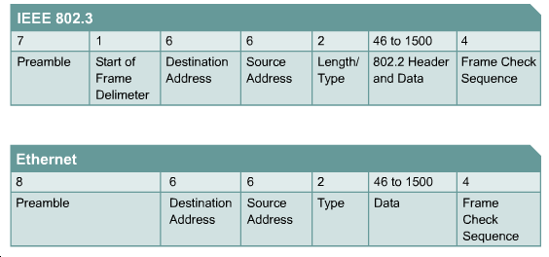
Some of the fields permitted or required in an 802.3 Ethernet Frame are:
- Preamble
- Start Frame Delimiter
- Destination Address
- Source Address
- Length/Type
- Data and Pad
- FCS
- Extension
The Preamble is an alternating pattern of ones and zeroes used for timing synchronization in the asynchronous 10 Mbps and slower implementations of Ethernet. Faster versions of Ethernet are synchronous, and this timing information is redundant but retained for compatibility.
A Start Frame Delimiter consists of a one-octet field that marks the end of the timing information, and contains the bit sequence 10101011.
The Destination Address field contains the MAC destination address. The destination address can be unicast, multicast (group), or broadcast (all nodes).
The Source Address field contains the MAC source address.
The Length/Type field supports two different uses.
If the value is less than 1536 decimal, 0x600 (hexadecimal), then the value indicates length. The length interpretation is used where the LLC Layer provides the protocol identification. The length indicates the number of bytes of data that follows this field.
If the value is equal to or greater than 1536 decimal (0600 hexadecimal), the value indicates that the type and contents of the Data field are decoded per the protocol indicated.The type value specifies the upper-layer protocol to receive the data after Ethernet processing is completed.
The Data and Pad field may be of any length that does not cause the frame to exceed the maximum frame size. The maximum transmission unit (MTU) for Ethernet is 1500 octets, so the data should not exceed that size. The content of this field is unspecified. An unspecified pad is inserted immediately after the user data when there is not enough user data for the frame to meet the minimum frame length. Ethernet requires that the frame be not less than 46 octets or more than 1518 octets.
A FCS contains a four byte CRC value. It is not possible to distinguish between corruption of the FCS itself and corruption of any preceding field used in the calculation.
Frame Part | Minimum Size Frame
Inter Frame Gap (9.6µs) | 12 octets
MAC Preamble (+ SFD) | 8 octets
MAC Destination Address | 6 octets
MAC Source Address | 6 octets
MAC Type (or Length) | 2 octets
Payload (Network PDU) | 46 octets
Check Sequence (CRC) | 4 octets
Total Frame Physical Size | 84 octets
Calculation of number of bit periods occupied by smallest size of Ethernet frame
Media Access Control
MAC refers to protocols that determine which computer on a shared-medium environment, or collision domain, is allowed to transmit the data. MAC, with LLC, comprises the IEEE version of the OSI Layer 2. MAC and LLC are sublayers of Layer 2. There are two broad categories of Media Access Control, deterministic (taking turns) and non-deterministic (first come, first served).
Examples of deterministic protocols include Token Ring and FDDI. In a Token Ring network, individual hosts are arranged in a ring and a special data token travels around the ring to each host in sequence. When a host wants to transmit, it seizes the token, transmits the data for a limited time, and then forwards the token to the next host in the ring. Token Ring is a collisionless environment as only one host is able to transmit at any given time.
Non-deterministic MAC protocols use a first-come, first-served approach. CSMA/CD is a simple system. The NIC listens for an absence of a signal on the media and starts transmitting. If two nodes transmit at the same time a collision occurs and none of the nodes are able to transmit.
Three common Layer 2 technologies are Token Ring, FDDI, and Ethernet. All three specify Layer 2 issues, LLC, naming, framing, and MAC, as well as Layer 1 signaling components and media issues. The specific technologies for each are as follows:
- Ethernet – logical bus topology (information flow is on a linear bus) and physical star or extended star (wired as a star)
- Token Ring – logical ring topology (in other words, information flow is controlled in a ring) and a physical star topology (in other words, it is wired as a star)
- FDDI – logical ring topology (information flow is controlled in a ring) and physical dual-ring topology (wired as a dual-ring)

CSMA/CD
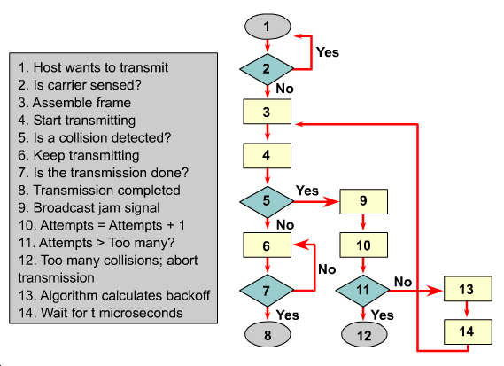
Bit Time
If the attached station is operating in full duplex then the station may send and receive simultaneously and collisions should not occur. Full-duplex operation also changes the timing considerations and eliminates the concept of slot time. Full-duplex operation allows for larger network architecture designs since the timing restriction for collision detection is removed.
10 Mbps and slower versions of Ethernet are asynchronous. Asynchronous means that each receiving station will use the eight octets of timing information to synchronize the receive circuit to the incoming data, and then discard it. 100 Mbps and higher speed implementations of Ethernet are synchronous. Synchronous means the timing information is not required, however for compatibility reasons the Preamble and SFD are present.
For all speeds of Ethernet transmission at or below 1000 Mbps, the standard describes how a transmission may be no smaller than the slot time. Slot time for 10 and 100-Mbps Ethernet is 512 bit-times, or 64 octets. Slot time for 1000-Mbps Ethernet is 4096 bit-times, or 512 octets. Slot time is calculated assuming maximum cable lengths on the largest legal network architecture. All hardware propagation delay times are at the legal maximum and the 32-bit jam signal is used when collisions are detected.
The actual calculated slot time is just longer than the theoretical amount of time required to travel between the furthest points of the collision domain, collide with another transmission at the last possible instant, and then have the collision fragments return to the sending station and be detected. For the system to work the first station must learn about the collision before it finishes sending the smallest legal frame size. To allow 1000-Mbps Ethernet to operate in half duplex the extension field was added when sending small frames purely to keep the transmitter busy long enough for a collision fragment to return. This field is present only on 1000-Mbps, half-duplex links and allows minimum-sized frames to be long enough to meet slot time requirements. Extension bits are discarded by the receiving station.
On 10-Mbps Ethernet one bit at the MAC layer requires 100 nanoseconds (ns) to transmit. At 100 Mbps that same bit requires 10 ns to transmit and at 1000 Mbps only takes 1 ns. As a rough estimate, 20.3 cm (8 in) per nanosecond is often used for calculating propagation delay down a UTP cable. For 100 meters of UTP, this means that it takes just under 5 bit-times for a 10BASE-T signal to travel the length the cable.
For CSMA/CD Ethernet to operate, the sending station must become aware of a collision before it has completed transmission of a minimum-sized frame. At 100 Mbps the system timing is barely able to accommodate 100 meter cables. At 1000 Mbps special adjustments are required as nearly an entire minimum-sized frame would be transmitted before the first bit reached the end of the first 100 meters of UTP cable. For this reason half duplex is not permitted in 10-Gigabit Ethernet.

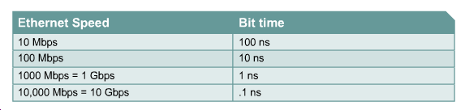
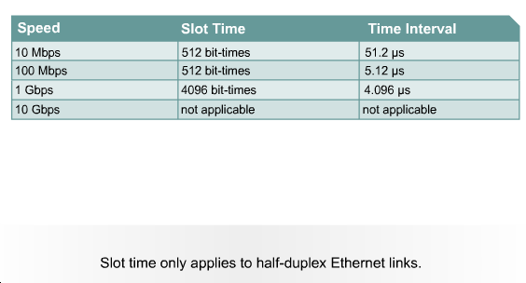

The minimum spacing between two non-colliding frames is also called the interframe spacing. This is measured from the last bit of the FCS field of the first frame to the first bit of the preamble of the second frame.
After a frame has been sent, all stations on a 10-Mbps Ethernet are required to wait a minimum of 96 bit-times (9.6 microseconds) before any station may legally transmit the next frame. On faster versions of Ethernet the spacing remains the same, 96 bit-times, but the time required for that interval grows correspondingly shorter. This interval is referred to as the spacing gap. The gap is intended to allow slow stations time to process the previous frame and prepare for the next frame.
A repeater is expected to regenerate the full 64 bits of timing information, which is the preamble and SFD, at the start of any frame. This is despite the potential loss of some of the beginning preamble bits because of slow synchronization. Because of this forced reintroduction of timing bits, some minor reduction of the interframe gap is not only possible but expected. Some Ethernet chipsets are sensitive to a shortening of the interframe spacing, and will begin failing to see frames as the gap is reduced. With the increase in processing power at the desktop, it would be very easy for a personal computer to saturate an Ethernet segment with traffic and to begin transmitting again before the interframe spacing delay time is satisfied.
After a collision occurs and all stations allow the cable to become idle (each waits the full interframe spacing), then the stations that collided must wait an additional and potentially progressively longer period of time before attempting to retransmit the collided frame. The waiting period is intentionally designed to be random so that two stations do not delay for the same amount of time before retransmitting, which would result in more collisions. This is accomplished in part by expanding the interval from which the random retransmission time is selected on each retransmission attempt. The waiting period is measured in increments of the parameter slot time.
If the MAC layer is unable to send the frame after sixteen attempts, it gives up and generates an error to the network layer. Such an occurrence is fairly rare and would happen only under extremely heavy network loads, or when a physical problem exists on the network.

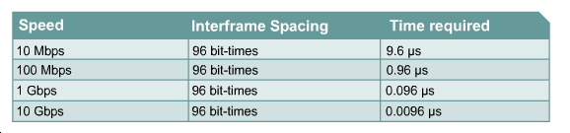
Types of Collision

- Local - occur during the first 64 octets, where a signal is detected on the RX pair at the same time it is sending on the TX pair, maybe due to a cable fault.

- Remote - occur during the first 64 octets, usually results from collisions occurring on the far side of a repeated connection. A repeater will not forward an over-voltage state, so a short frame may be received

- Late - occur after the first 64 octets, NIC assumes frame has been transmitted successfully, upper layers determine loss

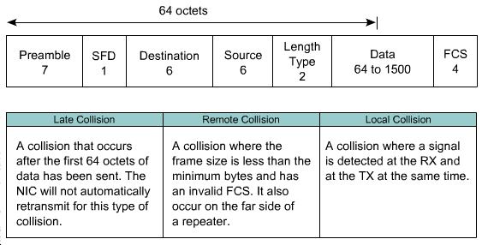
Types of Errors
Knowledge of typical errors is invaluable for understanding both the operation and troubleshooting of Ethernet networks.
The following are the sources of Ethernet error:
- Collision or runt – Simultaneous transmission occurring before slot time has elapsed
- Late collision – Simultaneous transmission occurring after slot time has elapsed
- Jabber, long frame and range errors – Excessively or illegally long transmission
- Short frame, collision fragment or runt – Illegally short transmission
- FCS error – Corrupted transmission
- Alignment error – Insufficient or excessive number of bits transmitted
- Range error – Actual and reported number of octets in frame do not match
- Ghost or jabber – Unusually long Preamble or Jam event
Jabber is defined in several places in the 802.3 standard as being a transmission of at least 20,000 to 50,000 bit times in duration. Most references to jabber are more properly called long frames.
A long frame is one that is longer than the maximum legal size, and takes into consideration whether or not the frame was tagged. It does not consider whether or not the frame had a valid FCS checksum. This error usually means that jabber was detected on the network.
A short frame is a frame smaller than the minimum legal size of 64 octets, with a good frame check sequence. Some protocol analyzers and network monitors call these frames “runts". In general the presence of short frames is not a guarantee that the network is failing.
The term runt is generally an imprecise slang term that means something less than a legal frame size. It may refer to short frames with a valid FCS checksum although it usually refers to collision fragments.
Frame Checksum Errors
High numbers of FCS errors from a single station usually indicates a faulty NIC and/or faulty or corrupted software drivers, or a bad cable connecting that station to the network. If FCS errors are associated with many stations, they are generally traceable to bad cabling, a faulty version of the NIC driver, a faulty hub port, or induced noise in the cable system.
A message that does not end on an octet boundary is known as an alignment error. This is often caused by bad software drivers, or a collision, and is frequently accompanied by a failure of the FCS checksum.
A frame with a valid value in the Length field but did not match the actual number of octets counted in the data field of the received frame is known as a range error.
Out of Range error, is reported when the value in the Length field indicates a data size that is too large to be legal.
Fluke Networks has coined the term ghost to mean energy (noise) detected on the cable that appears to be a frame, but is lacking a valid SFD. To qualify as a ghost, the frame must be at least 72 octets long, including the preamble Ground loops and other wiring problems are usually the cause of ghosting..
Ethernet Auto-negotiation
As Ethernet grew from 10 to 100 and 1000 Mbps, one requirement was to make each technology interoperable, even to the point that 10, 100, and 1000 interfaces could be directly connected. A process called Auto-Negotiation of speeds at half or full duplex was developed.
Auto-Negotiation takes place using Fast Link Pulse (FLP) signals. These signals are a modified version of the Normal Link Pulse (NLP) signals used for verifying link integrity, as defined in the original 10BASE-T specifications. The FLP signals are generated automatically at power-up, or may be selected manually through the management interface to an Auto-Negotiation device.
The Fast Link Pulse signals are designed to coexist with NLP signals, so that a 10BASE-T device that uses NLP signals will continue to detect the proper link integrity even when attached to an Auto-Negotiation hub that sends FLP signals. Like the original 10BASE-T link pulse, the FLP signals take place during idle times on the network link and do not interfere with normal traffic. Note that both Normal Link Pulses and Fast Link Pulses are specified only for twisted-pair media using eight-pin connectors, such as 100BASE-TX over unshielded twisted-pair. This means that network devices and repeater ports linked over fiber optic segments cannot participate in Auto-Negotiation.
The FLP signals are used to send information about device capabilities. The Auto-Negotiation protocol contains rules for device configuration based on this information. This is how a hub and the device attached to that hub can automatically negotiate and configure themselves to use the highest performance mode of operation.
The Auto-Negotiation feature is optional, and therefore the Auto-Negotiation protocol is designed to work with 100BASE-T interfaces that do not support Fast Link Pulses and Auto-Negotiation as well as older 10BASE-T interfaces that were built before Auto-Negotiation existed. The Auto-Negotiation system includes an optional management interface that allows you to disable Auto-Negotiation, or to manually force the negotiation process to take place. The management interface allows you to manually select a specific operational mode for a given hub port.
Link Establishment
Auto-Negotiation is optional for most Ethernet implementations. Gigabit Ethernet requires its implementation, though the user may disable it. Auto-Negotiation was originally defined for UTP implementations of Ethernet and has been extended to work with other fiber optic implementations.
If 100BASE-TX signaling is present, and the station supports 100BASE-TX, it will attempt to establish a link without negotiating. If either signaling produces a link or FLP bursts are received, the station will proceed with that technology. If a link partner does not offer an FLP burst, but instead offers NLPs, then that device is automatically assumed to be a 10BASE-T station. During this initial interval of testing for other technologies, the transmit path is sending FLP bursts. The standard does not permit parallel detection of any other technologies.
If a link is established through parallel detection, it is required to be half duplex. There are only two methods of achieving a full-duplex link. One method is through a completed cycle of Auto-Negotiation, and the other is to administratively force both link partners to full duplex. If one link partner is forced to full duplex, but the other partner attempts to Auto-Negotiate, then there is certain to be a duplex mismatch.
