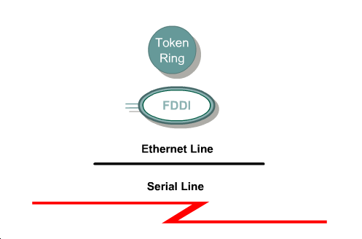

Each computer network can be built with many different media types. The function of media is to carry a flow of information through a LAN.

Each media has advantages and disadvantages. Some of the advantage or disadvantage comparisons concern:
- Cable length
- Cost
- Ease of installation
- Susceptibility to interference

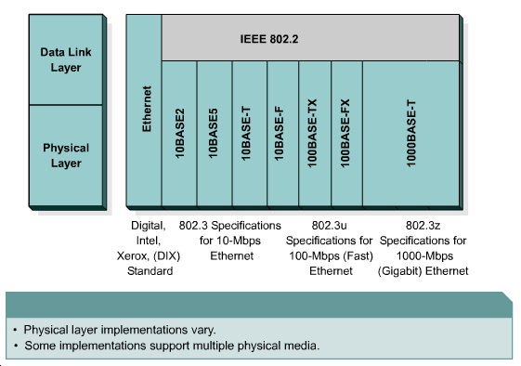

Ethernet is the most widely used LAN technology. Ethernet was first implemented by the Digital, Intel, and Xerox group, referred to as DIX. DIX created and implemented the first Ethernet LAN specification, which was used as the basis for the Institute of Electrical and Electronics Engineers (IEEE) 802.3 specification, released in 1980. Later, the IEEE extended 802.3 to three new committees known as 802.3u (Fast Ethernet), 802.3z (Gigabit Ethernet over Fiber), and 802.3ab (Gigabit Ethernet over UTP).

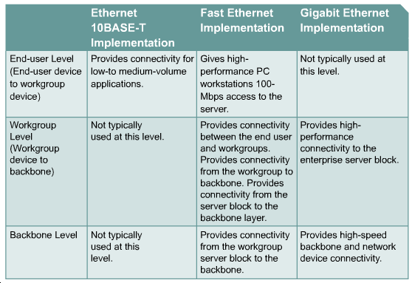

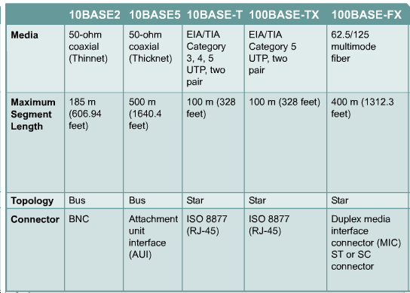

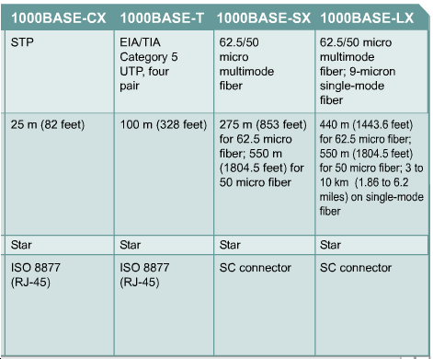

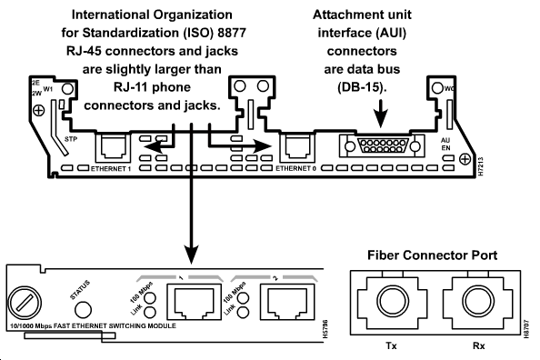

The cables and connector specifications used to support Ethernet implementations are derived from the Electronic Industries Association and the Telecommunications Industry Association (EIA/TIA) standards body. The categories of cabling defined for Ethernet are derived from the EIA/TIA-568 (SP-2840) Commercial Building Telecommunications Wiring Standards.

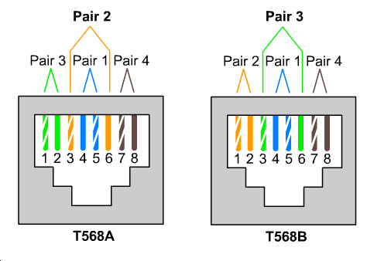

Use straight-through cables for the following cabling:
- Switch to router
- Switch to PC or server
- Hub to PC or server
Use crossover cables for the following cabling:
- Switch to switch
- Switch to hub
- Hub to hub
- Router to router
- PC to PC
- Router to PC

A repeater receives a signal, regenerates it, and passes it on. It can regenerate and retime network signals at the bit level to allow them to travel a longer distance on the media

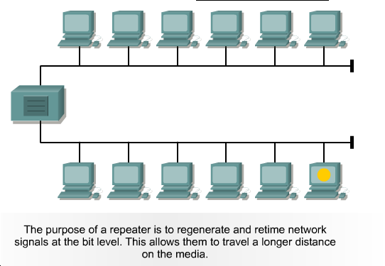

The 4 Repeater Rule

The Four Repeater Rule for 10-Mbps Ethernet states that no more than four repeaters can be used between hosts on a LAN. This rule is used to limit latency added to frame travel by each repeater. Too much latency on the LAN increases the number of late collisions and makes the LAN less efficient.

Hubs are actually multiport repeaters. In many cases, the difference between the two devices is the number of ports that each provides. While a typical repeater has just two ports, a hub generally has from four to twenty-four ports.

• Passive – A passive hub serves as a physical connection point only. It does not manipulate or view the traffic that crosses it. It does not boost or clean the signal. A passive hub is used only to share the physical media. As such, the passive hub does not need electrical power.
• Active – An active hub must be plugged into an electrical outlet because it needs power to amplify the incoming signal before passing it out to the other ports.
• Intelligent – Intelligent hubs are sometimes called smart hubs. These devices basically function as active hubs, but also include a microprocessor chip and diagnostic capabilities.

Devices attached to a hub receive all traffic traveling through the hub. Hubs can be thought of a “a bus in a box”. Networks that implement hubs are sometimes called “collapsed backbone networks”.

Hubs are also called concentrators.

Wireless media

- use Radio Frequency (RF), laser, infrared (IR), or satellite/microwaves to carry signals
- only permanent cabling can be to the access points for the network
- Workstations within the range of the wireless network can be moved easily without connecting and reconnecting network cabling
- transmitter converts source data to electromagnetic (EM) waves that are passed to the receiver
- receiver then converts these electromagnetic waves back into data for the destination
- networking device manufacturers build the transmitter and receiver into a single unit called a transceiver or wireless network card
- two most common wireless technologies used for networking are IR and RF
- IR technology has its weaknesses. Workstations and digital devices must be in the line of sight
- Radio Frequency technology allows devices to be in different rooms or even buildings. The limited range of radio signals restricts the use of this kind of network.
- RF technology can be on single or multiple frequencies. A single radio frequency is subject to outside interference and geographic obstructions.
- Spread spectrum avoids the problem of insecure data transmission by using multiple frequencies
- Two approaches currently being used to implement spread spectrum for WLAN transmissions are Frequency Hopping Spread Spectrum (FHSS) and Direct Sequence Spread Spectrum (DSSS)

Switches and bridges operate at the Data Link layer of the OSI model. The function of the bridge is to make intelligent decisions about whether or not to pass signals on to the next segment of a network.
When a bridge receives a frame on the network, the destination MAC address is looked up in the bridge table to determine whether to filter, flood, or copy the frame onto another segment. This decision process occurs as follows:
- If the destination device is on the same segment as the frame, the bridge blocks the frame from going on to other segments. This process is known as filtering.
- If the destination device is on a different segment, the bridge forwards the frame to the appropriate segment.
- If the destination address is unknown to the bridge, the bridge forwards the frame to all segments except the one on which it was received. This process is known as flooding.
If placed strategically, a bridge can greatly improve network performance.
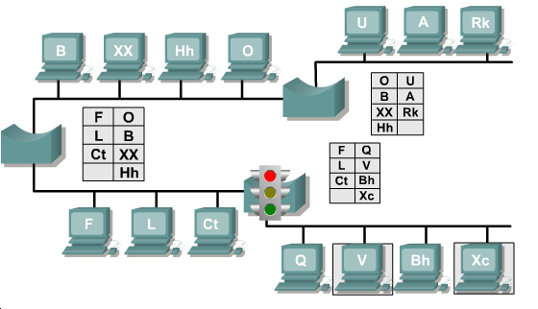

A switch is sometimes described as a multiport bridge. While a typical bridge may have just two ports linking two network segments, the switch can have multiple ports depending on how many network segments are to be linked. Like bridges, switches learn certain information about the data packets that are received from various computers on the network. Switches use this information to build forwarding tables to determine the destination of data being sent by one computer to another computer on the network.
Switches can easily replace hubs because switches work with existing cable infrastructures. This improves performance with a minimum of intrusion into an existing network.
2 basic operations.
- switching data frames.
- build and maintain switching tables

An Ethernet switch has many benefits:
- Switches operate at much higher speeds than bridges
- can support new functionality, such as virtual LANs.
- allows many users to communicate in parallel through the use of virtual circuits and dedicated network segments in a virtually collision-free environment.
- maximizes the bandwidth available on the shared medium
- very cost effective
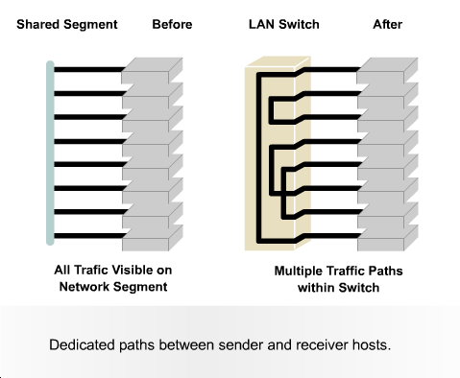

Bridges and Switches will not forward frames destined for a local segment, but they will forward broadcasts.

NICs are considered Layer 2 devices because each NIC carries a unique code called a MAC address.

The function of a NIC is to connect a host device to the network medium.

A transceiver converts one type of signal or connector to another. For example, a transceiver can connect a 15-pin AUI interface to an RJ-45 jack.

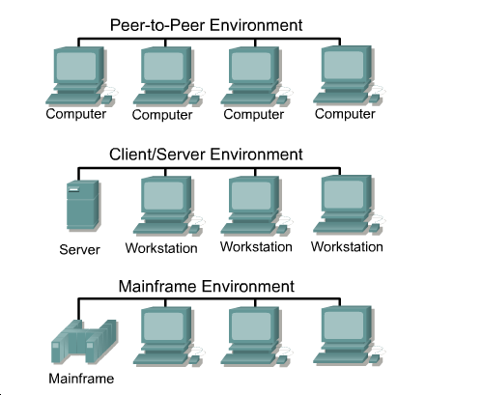

Peer – to – peer

- networked computers act as equal partners, or peers
- As peers, each computer can take on the client function or the server function.
- individual users control their own resources
- no central point of control or administration in the network ie security, access, backup
- relatively easy to install and operate
- No additional equipment is necessary beyond a suitable operating system
- A peer-to-peer network works well with 10 or fewer computers
- peer-to-peer networks do not scale well, their efficiency decreases rapidly as the number of computers on the network increases
- security may be difficult to maintain

Client/Server

- network services are located on a dedicated computer called a server.
- continuously available to respond to requests from clients for file, print, application, and other services
- Most network operating systems adopt the form of a client/server relationship
- Sevrer controls access, security, use and allocation of resources, and backups
- Although the aggregation of resources on server systems brings greater security, simpler access and coordinated control, the server introduces a single point of failure into the network
- Server systems also require additional hardware and specialized software that add to the cost

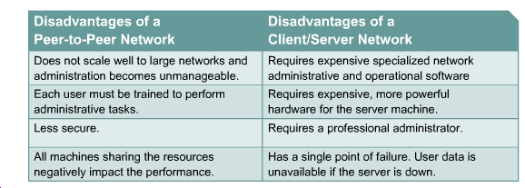

WANs use serial data transmission.

WAN connection types include ISDN, DSL, and cable modems.

WAN services such as dedicated leased lines run Point-to-Point Protocol (PPP) or Frame Relay. The speed of these connections ranges from 2400 bits per second (bps) to T1 service at 1.544 megabits per second (Mbps) and E1 service at 2.048 megabits per seconds (Mbps).

ISDN offers dial-on-demand connections or dial backup services. An ISDN Basic Rate Interface (BRI) is composed of two 64 kbps bearer channels (B channels) for data, and one delta channel (D channel) at 16 kbps used for signaling and other link-management tasks. PPP is typically used to carry data over the B channels.

The ISDN BRI has two types of interfaces, S/T and U interfaces. To interconnect the ISDN BRI port to the service-provider device, a UTP Category 5 straight-through cable with RJ-45 connectors, is used.

With the increasing demand for residential broadband high-speed services, DSL and cable modem connections are becoming more popular.

A CSU/DSU (Channel Service Unit/Data Service Unit) is a hardware device about the size of an external modem that converts digital data frames from the communications technology used on a local area network (LAN) into frames appropriate to a wide-area network (WAN) and vice versa.

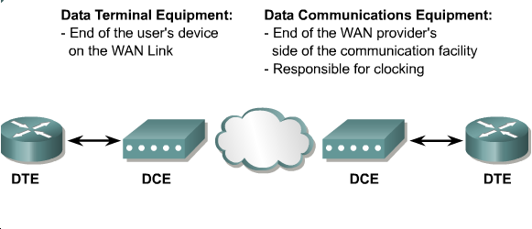

Serial cables that connect to routers have a DCE end and a DTE end. It is important that the DCE end is connected to the device which does the clocking for that connection.

A router is usually the DTE and needs a serial cable to connect to a DCE device like a CSU/DSU.

A phone cable and an RJ-11 connector are used to connect a router for DSL service.

Coaxial cable and a BNC connector are used to connect a router for cable service.

Rollover cable is used to connect a terminal and the console port of an internetworking device.

