- Differentiate between sine waves and square waves.

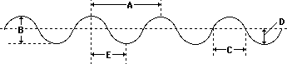
A = wavelength
D = amplitude
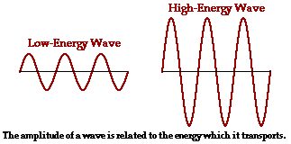

 Speed = Wavelength * Frequency

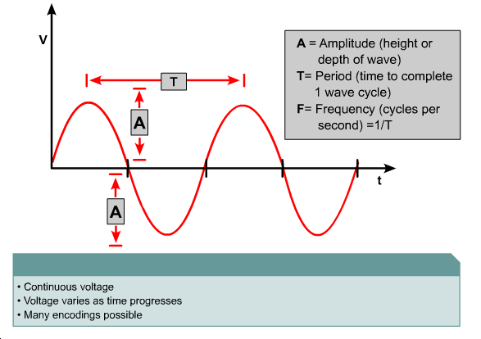

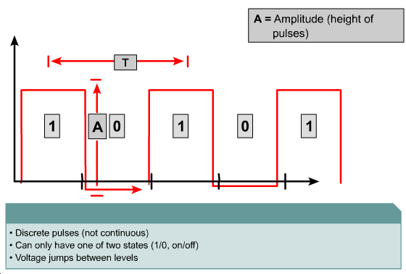
Sine waves are graphical representations of many natural occurrences that change regularly over time. Some examples of these occurrences are the distance from the earth to the sun, the distance from the ground while riding a Ferris wheel, and the time of day that the sun rises. Since sine waves are continuously varying, they are examples of analog waves.
Square waves, like sine waves, are periodic. However, square wave graphs do not continuously vary with time. The wave holds one value for some time, and then suddenly changes to a different value. This value is held for some time, and then quickly changes back to the original value. Square waves represent digital signals, or pulses. Like all waves, square waves can be described in terms of amplitude, period, and frequency.
Define and calculate exponents and logarithms.
The decibel (dB) is a measurement unit important in describing networking signals. The decibel is related to the exponents and logarithms described in prior sections. There are two formulas for calculating decibels:
- dB = 10 log₁₀ (P_{final} / P_{ref})
- dB = 20 log₁₀ (V_{final} / V_{reference})
The variables represent the following values:
- dB measures the loss or gain of the power of a wave. Decibels are usually negative numbers representing a loss in power as the wave travels, but can also be positive values representing a gain in power if the signal is amplified
- log₁₀ implies that the number in parenthesis will be transformed using the base 10 logarithm rule
- P_{final} is the delivered power measured in Watts
- P_{ref} is the original power measured in Watts
- V_{final} is the delivered voltage measured in Volts
- V_{reference} is the original voltage measured in Volts

Define and calculate decibels.
The first formula describes decibels in terms of power (P), and the second in terms of voltage (V). Typically, light waves on optical fiber and radio waves in the air are measured using the power formula. Electromagnetic waves on copper cables are measured using the voltage formula.
An oscilloscope is an important electronic device used to view electrical signals such as voltage waves and pulses. The x-axis on the display represents time, and the y-axis represents voltage or current. There are usually two y-axis inputs, so two waves can be observed and measured at the same time.
Analyzing signals using an oscilloscope is called time-domain analysis, because the x-axis or domain of the mathematical function represents time. Engineers also use frequency-domain analysis to study signals. In frequency-domain analysis, the x-axis represents frequency. An electronic device called a spectrum analyzer creates graphs for frequency-domain analysis.
All communications systems have some amount of noise. Even though noise cannot be eliminated, its effects can be minimized if the sources of the noise are understood. There are many possible sources of noise:
- Nearby cables which carry data signals
- Radio frequency interference (RFI), which is noise from other signals being transmitted nearby
- Electromagnetic interference (EMI), which is noise from nearby sources such as motors and lights
- Laser noise at the transmitter or receiver of an optical signal
Noise that affects all transmission frequencies equally is called white noise. Noise that only affects small ranges of frequencies is called narrowband interference. When detected on a radio receiver, white noise would interfere with all radio stations. Narrowband interference would affect only a few stations whose frequencies are close together. When detected on a LAN, white noise would affect all data transmissions, but narrowband interference might disrupt only certain signals. If the band of frequencies affected by the narrowband interference included all frequencies transmitted on the LAN, then the performance of the entire LAN would be compromised.
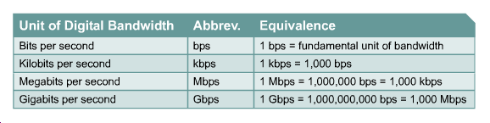
Differentiate between digital bandwidth and analog bandwidth.
Analog bandwidth typically refers to the frequency range of an analog electronic system. Analog bandwidth could be used to describe the range of frequencies transmitted by a radio station or an electronic amplifier. The units of measurement for analog bandwidth is Hertz, the same as the unit of frequency. Examples of analog bandwidth values are 3 kHz for telephony, 20 kHz for audible signals, 5 kHz for AM radio stations, and 200 MHz for FM radio stations.
Digital bandwidth measures how much information can flow from one place to another in a given amount of time. The fundamental unit of measurement for digital bandwidth is bits per second (bps). Since LANs are capable of speeds of millions of bits per second, measurement is expressed in kilobits per second (Kbps) or megabits per second (Mbps). Physical media, current technologies, and the laws of physics limit bandwidth.
During cable testing, analog bandwidth is used to determine the digital bandwidth of a copper cable. Analog frequencies are transmitted from one end and received on the opposite end. The two signals are then compared, and the amount of attenuation of the signal is calculated. In general, media that will support higher analog bandwidths without high degrees of attenuation will also support higher digital bandwidths.
Attenuation is the decrease in signal amplitude over the length of a link. Long cable lengths and high signal frequencies contribute to greater signal attenuation. For this reason, attenuation on a cable is measured by a cable tester using the highest frequencies that the cable is rated to support. Attenuation is expressed in decibels (dB) using negative numbers. Smaller negative dB values are an indication of better link performance.
There are several factors that contribute to attenuation. The resistance of the copper cable converts some of the electrical energy of the signal to heat. Signal energy is also lost when it leaks through the insulation of the cable and by impedance caused by defective connectors.
Impedance is a measurement of the resistance of the cable to alternating current (AC) and is measured in ohms. The normal, or characteristic, impedance of a Cat5 cable is 100 ohms. If a connector is improperly installed on Cat5, it will have a different impedance value than the cable. This is called an impedance discontinuity or an impedance mismatch.
Impedance discontinuities cause attenuation because a portion of a transmitted signal will be reflected back to the transmitting device rather than continuing to the receiver, much like an echo. This effect is compounded if there are multiple discontinuities causing additional portions of the remaining signal to be reflected back to the transmitter. When this returning reflection strikes the first discontinuity, some of the signal rebounds in the direction of the original signal, creating multiple echo effects. The echoes strike the receiver at different intervals making it difficult for the receiver to accurately detect data values on the signal. This is called jitter and results in data errors.
The combination of the effects of signal attenuation and impedance discontinuities on a communications link is called insertion loss. Proper network operation depends on constant characteristic impedance in all cables and connectors, with no impedance discontinuities in the entire cable system.
Define crosstalk, near-end crosstalk, far-end crosstalk, and power sum near-end crosstalk.
There are three distinct types of crosstalk:
- Near-end Crosstalk (NEXT)
- Far-end Crosstalk (FEXT)
- Power Sum Near-end Crosstalk (PSNEXT)
Near-end crosstalk (NEXT) is computed as the ratio of voltage amplitude between the test signal and the crosstalk signal when measured from the same end of the link. This difference is expressed in a negative value of decibels (dB).

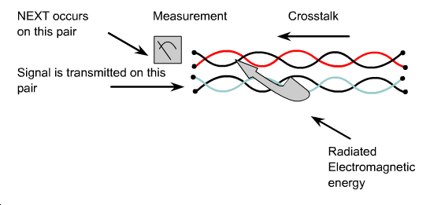
Due to attenuation, crosstalk occurring further away from the transmitter creates less noise on a cable than NEXT. This is called far-end crosstalk, or FEXT. The noise caused by FEXT still travels back to the source, but it is attenuated as it returns. Thus, FEXT is not as significant a problem as NEXT.
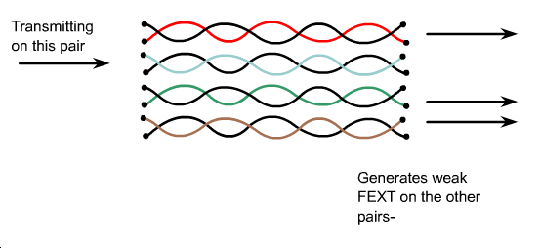

Power Sum NEXT (PSNEXT) measures the cumulative effect of NEXT from all wire pairs in the cable. PSNEXT is computed for each wire pair based on the NEXT effects of the other three pairs. The combined effect of crosstalk from multiple simultaneous transmission sources can be very detrimental to the signal. TIA/EIA-568-B certification now requires this PSNEXT test.
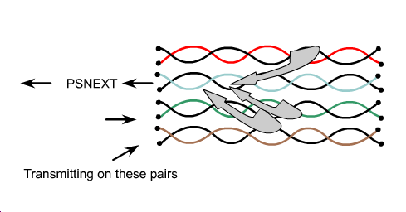
Describe the ten copper cable tests defined in TIA/EIA-568-B.
The ten primary test parameters that must be verified for a cable link to meet TIA/EIA standards are:
- Wire map
- Insertion loss
- Near-end crosstalk (NEXT)
- Power sum near-end crosstalk (PSNEXT)
- Equal-level far-end crosstalk (ELFEXT)
- Power sum equal-level far-end crosstalk (PSELFEXT)
- Return loss
- Propagation delay
- Cable length
- Delay skew
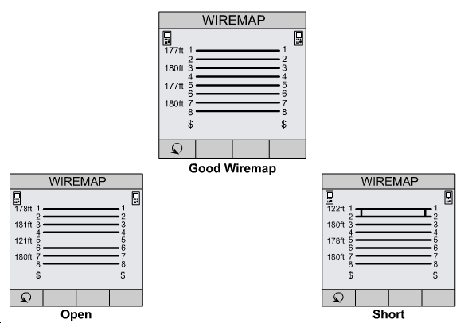

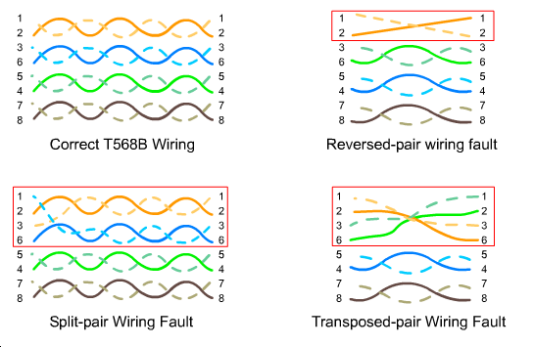
Define basic terminology related to time, frequency, and noise.
Crosstalk is measured in four separate tests. A cable tester measures NEXT by applying a test signal to one cable pair and measuring the amplitude of the crosstalk signals received by the other cable pairs. The NEXT value, expressed in decibels, is computed as the difference in amplitude between the test signal and the crosstalk signal measured at the same end of the cable. Remember, because the number of decibels that the tester displays is a negative number, the larger the number, the lower the NEXT on the wire pair. As previously mentioned, the PSNEXT test is actually a calculation based on combined NEXT effects.
The equal-level far-end crosstalk (ELFEXT) test measures FEXT. Pair-to-pair ELFEXT is expressed in dB as the difference between the measured FEXT and the insertion loss of the wire pair whose signal is disturbed by the FEXT. ELFEXT is an important measurement in Ethernet networks using 1000BASE-T technologies. Power sum equal-level far-end crosstalk (PSELFEXT) is the combined effect of ELFEXT from all wire pairs.
Define and describe the affects of attenuation and impedance mismatch.
Return loss is a measure in decibels of reflections that are caused by the impedance discontinuities at all locations along the link. Recall that the main impact of return loss is not on loss of signal strength. The significant problem is that signal echoes caused by the reflections from the impedance discontinuities will strike the receiver at different intervals causing signal jitter.

Compare and contrast noise levels on various types of cabling.
Propagation delay measurements are the basis of the cable length measurement. TIA/EIA-568-B-1 specifies that the physical length of the link shall be calculated using the wire pair with the shortest electrical delay. Testers measure the length of the wire based on the electrical delay as measured by a Time Domain Reflectometry (TDR) test, not by the physical length of the cable jacket. Since the wires inside the cable are twisted, signals actually travel farther than the physical length of the cable. When a cable tester makes a TDR measurement, it sends a pulse signal down a wire pair and measures the amount of time required for the pulse to return on the same wire pair.
The TDR test is used not only to determine length, but also to identify the distance to wiring faults such as shorts and opens. When the pulse encounters an open, short, or poor connection, all or part of the pulse energy is reflected back to the tester. This can calculate the approximate distance to the wiring fault. The approximate distance can be helpful in locating a faulty connection point along a cable run, such as a wall jack.
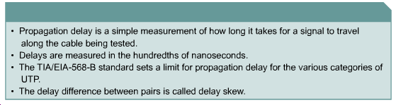
Testing fiber optic cable primarily involves shining a light down the fiber and measuring whether a sufficient amount of light reaches the receiver.
On a fiber optic link, the acceptable amount of signal power loss that can occur without dropping below the requirements of the receiver must be calculated. This calculation is referred to as the optical link loss budget. A fiber test instrument checks whether the optical link loss budget has been exceeded. If the fiber fails the test, the cable test instrument should indicate where the optical discontinuities occur along the length of the cable link. Usually, the problem is one or more improperly attached connectors.
Describe the difference between Category 5 and Category 6 cable.
On June 20, 2002, the Category 6 (or Cat 6) addition to the TIA-568 standard was published. The official title of the standard is ANSI/TIA/EIA-568-B.2-1. This new standard specifies the original set of performance parameters that need to be tested for Ethernet cabling as well as the passing scores for each of these tests. Cables certified as Cat 6 cable must pass all ten tests.
Although the Cat 6 tests are essentially the same as those specified by the Cat 5 standard, Cat 6 cable must pass the tests with higher scores to be certified. Cat6 cable must be capable of carrying frequencies up to 250 MHz and must have lower levels of crosstalk and return loss.
Cat 6 will allow up to double the bandwidth of Cat5.

