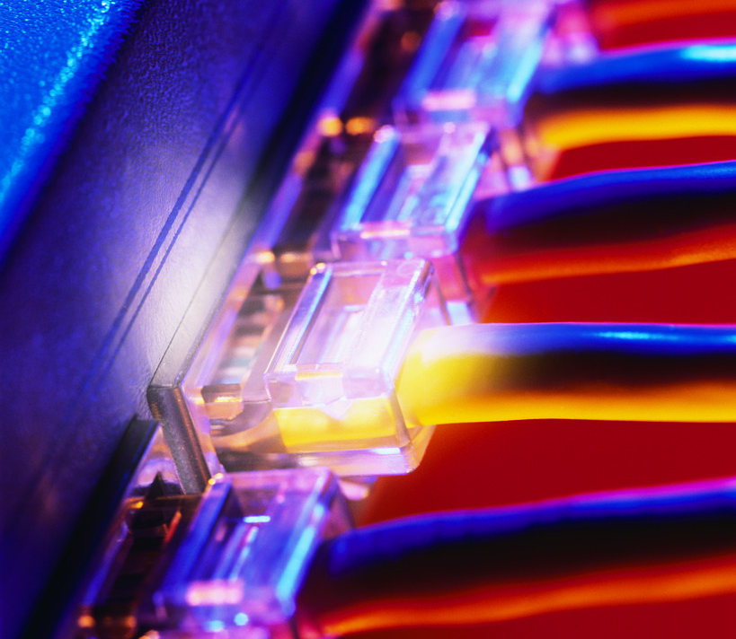
SEMESTER 1 MODULE 4
Cable Testing
v. 3.1.1

4.1.1 | Define period as it relates to the measurement of ocean waves. | The period of the waves is the amount of time between each wave, measured in seconds.
4.1.1 | Define frequency. | The frequency is the number of waves that reach the shore each second, measured in hertz (Hz).
4.1.1 | Define Hertz (Hz). | 1 Hz is equal to 1 wave per second, or 1 cycle per second.
4.1.1 | The amplitude of an electrical signal still represents height, but it is measured in what? | in volts (V)
4.1.1 | The period is the amount of time that it takes to complete 1 cycle. This is measured in what? | seconds.
4.1.1 | The frequency of an electrical signal is ________ ______________________ This is measured in Hz. | the number of complete cycles per second.
4.1.1 | If a disturbance is deliberately caused, and involves a fixed, predictable duration, it is called a ________. | pulse
4.1.2 | List four descriptors of Sine waves. | - periodic, which means that they repeat the same pattern at regular intervals.  - vary continuously, which means that no adjacent points on the graph have the same value.  - graphical representations of many natural occurrences that change regularly over time.  - analog waves
4.1.2 | Draw an example of a Sine wave.
 | List four descriptors of Sine waves. | - Periodic  - Do not continuously vary with time.  - The wave maintains one value and then suddenly changes to a different value.  - After a short amount of time it changes back to the original value.
 | Square waves represent what ? | digital signals, or pulses.
 | Like all waves, square waves can be described in terms of amplitude, period, and frequency.
 | Draw an example of a Square wave.
4.1.3 | Base 2 is what type of numbering system? | Binary
4.1.3 | Base 10 is what type of numbering system? | Decimal
4.1.3 | Base 16 is what type of numbering system? | Hexadecimal
4.1.5 | What is an important electronic device used to view electrical signals such as voltage waves and pulses. | An oscilloscope
4.1.7 | Noise related to communications refers to what? | undesirable signals.
4.1.7 | List the possible sources of noise: | - Nearby cables that carry data signals  - RFI from other signals that are transmitted nearby  - EMI from nearby sources such as motors and lights  - Laser noise at the transmitter or receiver of an optical signal
4.1.7 | Define white noise. | Noise that affects all transmission frequencies equally
4..1.8 | Analog bandwidth could be used to describe the range of frequencies transmitted by what? | by a radio station or an electronic amplifier.
 | What measures how much information can flow from one place to another in a given amount of time? | Digital bandwidth
4.2.1 | Data signals are represented by voltage levels that represent what? | binary ones and zeros.
4.2.1 | New cable installations should be made with the best _____________, ______________ and ____________. | cable, connectors, and interconnect devices
4.2.1 | List the advantages of Coaxial cable. | - less noisy  - reduced signal loss
4.2.1 | List the disadvantages of Coaxial cable. | - more expensive  - The need to ground the shielding and the bulky size of coaxial cable make it more difficult to install than other copper cabling.
4.2.1 | List the two types of twisted-pair cable. | shielded twisted-pair (STP) and unshielded twisted pair (UTP).
4.2.1 | Fiber-optic cable increases and decreases the intensity of _________ to represent binary ones and zeros in data transmissions. | of light
4.2.1 | Pptical fiber is often used between __________ and __________________ within a building. As costs decrease and speeds increase, optical fiber may become a more commonly used LAN media. | buildings and between floors
4.2.2 | What is the decrease in signal amplitude over the length of a link. | Attenuation
4.2.2 | What contributes to attenuation? | - Long cable lengths  - High signal frequencies  - Signal energy loss  - Impedence caused by defective connectors
4.2.2 | Define Impedance. | Impedance is a measurement of the resistance of the cable to alternating current (AC) and is measured in ohms.
 | If a connector is improperly installed on Category 5, it will have a different impedance value than the cable. This is called what? | an impedance discontinuity or an impedance mismatch.
4.2.3 | The transmission of signals from one wire to a nearby wire is called what? | Crosstalk
4.2.3 | Crosstalk is more destructive at _________ transmission frequencies. | higher
4.2.3 | Twisted wire pairs in a cable are also more resistant to what? | crosstalk or noise signals from adjacent wire pairs.
4.2.3 | When connectors are attached to the ends of UTP cable, the wire pairs should be what? | untwisted as little as possible to ensure reliable LAN communications.
4.2.4 | List the three types of crosstalk. | - Near-end Crosstalk (NEXT)  - Far-end Crosstalk (FEXT)  - Power Sum Near-end Crosstalk (PSNEXT)
4.2.5 | List the ten primary test parameters that must be verified for a cable link to meet TIA/EIA standards. | - Wire map  - Insertion loss  - Near-end crosstalk (NEXT)  - Power sum near-end crosstalk (PSNEXT)  - Equal-level far-end crosstalk (ELFEXT)  - Power sum equal-level far-end crosstalk (PSELFEXT)  - Return loss  - Propagation delay  - Cable length  - Delay skew
4.2.5 | A NIC transmits signals on ___________. | pins 1 and 2
4.2.5 | A NIC receives signals on ____________. | pins 3 and 6
4.2.7 | Testers measure the length of the wire based on the _______________ as measured by a Time Domain Reflectometry (TDR) test, not by the physical length of the cable jacket. | electrical delay
4.2.7 | The TDR test is used not only to determine length, but also to identify what? | the distance to wiring faults such as shorts and opens
4.2.8 | What are the main cause of light reflection and signal strength loss in optical fiber and with UTP cable? | improperly installed connectors
4.2.9 | Category 6 cable must pass the tests with higher scores to be certified. Category 6 cable must be capable of carrying frequencies up to ___________ and must have ____________________________. | 250 MHz  lower levels of crosstalk and return loss

