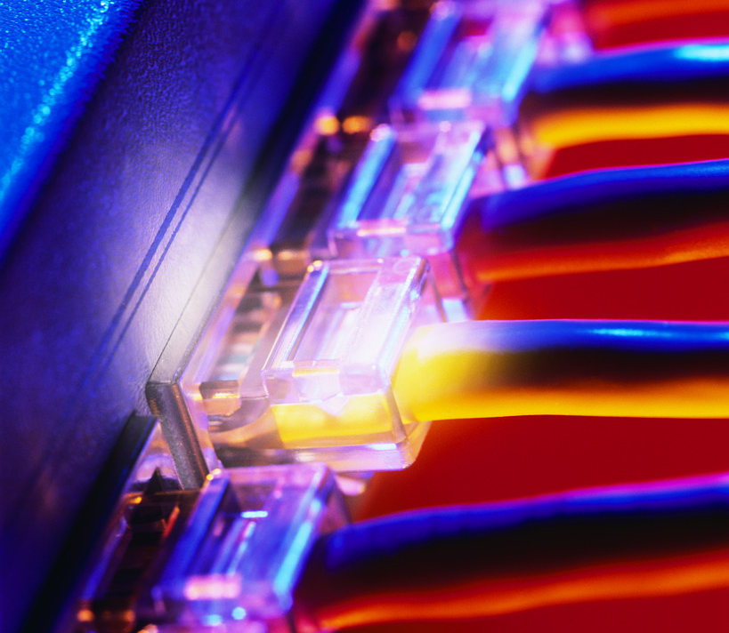
SEMESTER 1 MODULE 4
Cable Testing
v. 3.1.1

4.1.1 | Define period as it relates to the measurement of ocean waves.
4.1.1 | Define frequency.
4.1.1 | Define Hertz (Hz).
4.1.1 | The amplitude of an electrical signal still represents height, but it is measured in what?
4.1.1 | The period is the amount of time that it takes to complete 1 cycle. This is measured in what?
4.1.1 | The frequency of an electrical signal is ________ ______________________ This is measured in Hz.
4.1.1 | If a disturbance is deliberately caused, and involves a fixed, predictable duration, it is called a ________.
4.1.2 | List four descriptors of Sine waves.
4.1.2 | Draw an example of a Sine wave.
 | List four descriptors of Sine waves.
 | Square waves represent what ?
 | Like all waves, square waves can be described in terms of amplitude, period, and frequency.
 | Draw an example of a Square wave.
4.1.3 | Base 2 is what type of numbering system?
4.1.3 | Base 10 is what type of numbering system?
4.1.3 | Base 16 is what type of numbering system?
4.1.5 | What is an important electronic device used to view electrical signals such as voltage waves and pulses.
4.1.7 | Noise related to communications refers to what?
4.1.7 | List the possible sources of noise:
4.1.7 | Define white noise.
4..1.8 | Analog bandwidth could be used to describe the range of frequencies transmitted by what?
 | What measures how much information can flow from one place to another in a given amount of time?
4.2.1 | Data signals are represented by voltage levels that represent what?
4.2.1 | New cable installations should be made with the best _____________, ______________ and ____________.
4.2.1 | List the advantages of Coaxial cable.
4.2.1 | List the disadvantages of Coaxial cable.
4.2.1 | List the two types of twisted-pair cable.
4.2.1 | Fiber-optic cable increases and decreases the intensity of _________ to represent binary ones and zeros in data transmissions.
4.2.1 | Pptical fiber is often used between __________ and __________________ within a building. As costs decrease and speeds increase, optical fiber may become a more commonly used LAN media.
4.2.2 | What is the decrease in signal amplitude over the length of a link.
4.2.2 | What contributes to attenuation?
4.2.2 | Define Impedance.
 | If a connector is improperly installed on Category 5, it will have a different impedance value than the cable. This is called what?
4.2.3 | The transmission of signals from one wire to a nearby wire is called what?
4.2.3 | Crosstalk is more destructive at _________ transmission frequencies.
4.2.3 | Twisted wire pairs in a cable are also more resistant to what?
4.2.3 | When connectors are attached to the ends of UTP cable, the wire pairs should be what?
4.2.4 | List the three types of crosstalk.
4.2.5 | List the ten primary test parameters that must be verified for a cable link to meet TIA/EIA standards.
4.2.5 | A NIC transmits signals on ___________.
4.2.5 | A NIC receives signals on ____________.
4.2.7 | Testers measure the length of the wire based on the _______________ as measured by a Time Domain Reflectometry (TDR) test, not by the physical length of the cable jacket.
4.2.7 | The TDR test is used not only to determine length, but also to identify what?
4.2.8 | What are the main cause of light reflection and signal strength loss in optical fiber and with UTP cable?
4.2.9 | Category 6 cable must pass the tests with higher scores to be certified. Category 6 cable must be capable of carrying frequencies up to ___________ and must have ____________________________.

