Online Activity as Treatment Effect: from Correlation to Causal Inference

Working Paper
May 2018
Dr W.B. Tyler, Consultant to the Delivering Success Project

TABLE OF CONTENTS
Questions addressed: 2
Introduction 3
Analytical strategy 3
1. Predicting Success: Estimating the Online Activity Effect by Regression Modelling 4
2. Correcting for Endogenous Treatment Bias: From Correlation to Causality 9
3. Interpreting the Counterfactual Model: from Causal Inference to Educational Practice 12
Summary and Conclusions 14
Bibliography 15
Technical Appendices 17

LIST OF FIGURES
Fig. 2(a) & 2(b) Marginsplots of Regression of Grade Scale on Learnline Activity Score (logscale) Learnline sample: ( Rsq=.10, p<.0000); Collaborate sample:Rsq= .04, p<.000) (a) Learnline Activity and Numeric Grade for Unit 5
(b) Collaborate Participation and Numeric Grade for Unit 6
Fig. 3 (a) Marginsplot of Grade Scale on Learnline Activity, Covariates and Pedagogic Context (n=8,970; R2 adj. = .23) 7
Fig. 3(b) Marginsplot of Grade Scale on Collaborate Activity, Covariates Context Terms* (n=3,898; R2 adj. = .17) 8
Fig. 4 Potential Average Numeric Grade Gains by Online Activity and Pedagogic Context Error Bars (95% C.I.) based on Appendix Tables A.6 & A.7) 11
Fig. 5 Comparison of Predicted Numerical Gains in Grade Awarded: Three Regression Models “Untreated” (left-hand scoreline) vs “Treated” (right-hand scoreline) 12
Fig. 6 Comparison of Distributions of Predicted Numerical Grade Scores*: Learnline and Collaborate 13

LIST OF TABLES
Table 1 Marginal Numerical Grade Scores and Gains by Online Activity Group and Activity Type 5
(Unadjusted scores; Learnline n= 9,015; Collaborate n=3,905) 5
Table 2. Predicted Numerical Grade Scores by Online Activity Group and Activity Type (Controlling for Pedagogic Context and Selected Student Background Attributes) 7
Table 3 Treatment Groups for Learnline Activity and Collaborate Participation 10

Questions addressed:
How well do reported levels of student Learnline activity and Collaborate participation predict the Grade Awarded in a range of Common and Core first year units when the confounding factors (both individual and contextual) have been controlled?
What might have been the effect of these activities in unit grade awarded, had students been randomly assigned to different levels of Learnline activity or Collaborate participation?
In addressing this question, we have found that:
- Linear regression analysis showed a positive and statistically significant marginal effect of levels of both Learnline Activity and Collaborate Participation on Grade Awarded in the both Common and Core first year units.
- A positive and statistically significant effect persisted after controlling for both student demographics and Pedagogic Context (a categorical variable defined as four combinations of external vs internal attendance by Common vs Core first year unit types).
- The four Pedagogic Context combinations exerted contrasting patterns of mediation of the effects of online Activity, with consistent linear gains for Learnline Activity but variable and inconsistent marginal effects for Collaborate Participation.
- Results for regression modelling for Learnline Activity showed greater estimated marginal gains for the Core units, though from a lower average awarded grade base across both modes of attendance; for Collaborate Participation, External mode for both unit categories showed significant positive gains.
- Results from potential outcomes/counterfactual modelling that simulate randomised assignment designs provided evidence for a positive strong, positive causal, linear marginal effect of higher levels of online activity/ participation on potential grades across all first year units for both Learnline and Collaborate samples.
- A much larger marginal effect of online levels on predicted grades attributed to higher levels of online activity/participation by counterfactual modelling was due to prediction of lower grades (by about a full numerical grade) for “untreated” or lower activity/ participation groups, rather than a predicted boost to those of the “treated” (between a quarter to a third of a numerical grade).
- A large effect for unmeasured variables appeared to decrease the likelihood of higher level of online activity or participation. This finding suggests that research that could identify and remediate these inhibitors to engagement and has considerable potential for boosting student outcomes across the range of pedagogic contexts.

Introduction
In this section of the Delivering Success report, we looked into the causal background to the correlations between online Activity and student grades reported in the previous section.
We addressed the following question:
How well do reported levels of student Learnline and Collaborate Activity explain the Grade Awarded in a range of Common and Core first year units, when the effects of confounding factors (both observed and unobserved) have been both controlled?
Because there are a host of other variables that are associated with a student’s level of engagement in online activity, this question was addressed in two distinct stages:
- Do the associations between online activity and student outcomes, as graphed in the previous section retain their statistical significance, after we adjust for a range of student background characteristics, as well as the context of learning e.g. the type of first year unit and the mode or attendance?
- What causal inferences can we draw from our data and findings, should students have been assigned randomly to different levels of online “treatment” rather than being allowed to self-select their own levels of online engagement?

Analytical strategy
We explored this question in two ways:
- By identifying the strength and significance of the online activity effect on awarded grades by controlling these known and measured student and contextual factors through statistical methods. The most common one, also used here, is that of univariate and multivariate linear regression.
- Since is not possible to make a direct causal inference as tested in a randomised control treatment design (the so-called “gold standard” of evaluation studies), we used recently available counterfactual outcomes or potential outcomes modelling to correct for the biases due to the influence of unobserved effects acting simultaneously on activity levels and on grade awarded (sometimes called an “endogenous treatment effect”).
- If a significant “endogenous treatment” effect of online activity or participation were to be detected by counterfactual techniques: (a) how might the sign of the correlation (whether positive or negative) between the source of bias on the outcome be interpreted in causal terms?; (b) what implications would this finding hold for purposes of online educational practice and future research into the effects of online activity on student success?
Sample and Variables
Two samples of both external and internal enrolments from Sem. II 2013 through Sem. I 2015 were studied, the first for general Blackboard/Learnline activity that included all enrolments with at least one access event (n=9,015) and, for the second sample, a limited group of Collaborate (virtual classroom) self-selecting observations (n=3,905).

Online activity as “treatment”

Regression Modelling
For the regression modelling, the “treatment” for both samples were continuous variables constructed from the activity data specific to each mode of engagement. For the Learnline sample, activity was based on the log-transformed aggregated mean deviation scores of online activity recorded over three measured activities: the number of accesses or “hits”, the number of “clicks” online, and the total minutes online. For the Collaborate sample, participation scores were based on the percentage of available sessions attended and recordings viewed. (Figs.2(a) and 2(b); Appendix Tables A.2 & A.3).

Counterfactual modelling
For counterfactual modelling, in order to create a binary treatment assignment effect, the log-transformed Learnline scores below the mean of zero were scored as “untreated” (ie “0” , those above as “treated (“1”). For the Collaborate sample, the lowest quartile of the log-transformed participation scores were similarly defined as “untreated” (scored “0”), while the three upper quartiles were defined as “treated” (1”).
Covariates: Student-specific covariates were selected by a previous stepwise regression procedure (Male Gender, Age, NESB, the presence of an ATAR (Tertiary Entrance) scored also as a dummy variable, four Bases of Admission as dummy variables in the “treatment” equation, and two in the outcome equation . Also included was a four-category combination of pedagogic modes (external/ internal attendance) by unit type (Common or Core).
Outcome measure was the raw numerical grade score - range 3 (Pass Conceded) to 7 (High Distinction) whose distribution is shown in Fig. 2 for both samples.

1. Predicting Success: Estimating the Online Activity Effect by Regression Modelling
The following model (Fig. 1) puts the first question in the form of a multivariate regression model. This model allows us to isolate the effect of online Activity for both Learnline and Collaborate samples (the red arrow).
Fig. 1 Estimating the Effect of Learnline Activity in Predictive Context: A Regression Model
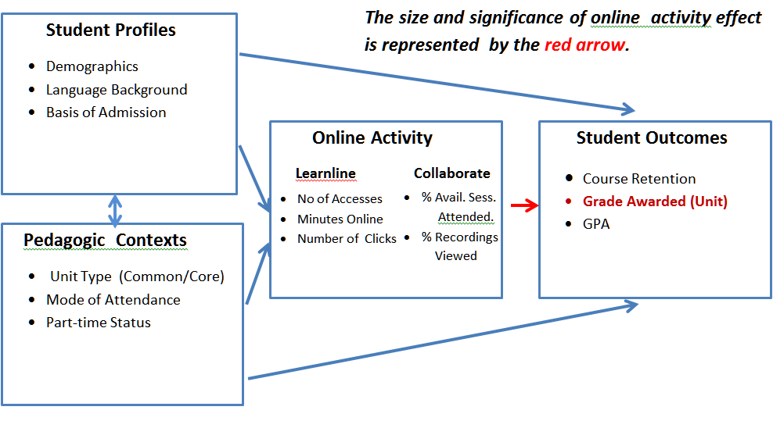
Analytical Strategy: Regression Analysis – Bivariate and Multivariate : For a benchmark estimation, we first looked at the effect of each online category, using Ordinarly Least Squares regression of the numerical grade awarded, on a binary measure of online activity/ participation as a single independent variable (Stata regress with robust option), without adjustment for either pedagogic context or individual student socio-demographic. The results are displayed in Table 1 and in Figures 2(a) for Learnline Activity and 2(b)
Table 1 Marginal Numerical Grade Scores and Gains by Online Activity Group and Activity Type
(Unadjusted scores; Learnline n= 9,015; Collaborate n=3,905)
Learnline Activity | Margin | Std. Err. | t | P>t | [95% Conf. | Interval]
Lower Activity ("Untreated") | 4.665 | 0.018 | 252.410 | 0.000 | 4.629 |  | 4.702
Higher Activity ("Treated") | 5.265 | 0.013 | 401.560 | 0.000 | 5.239 |  | 5.291
Higher vs Lower Activity | 0.600 | 0.023 | 25.940 | 0.000 | 0.554 |  | 0.645
Collorate Participation
Lower Participation("Untreated") | 5.045 | 0.033 | 153.850 | 0.000 | 4.980 |  | 5.109
Higher Participation ("Treated") | 5.394 | 0.019 | 290.400 | 0.000 | 5.358 |  | 5.430
Higher vs Lower Participation | 0.349 | 0.038 | 9.270 | 0.000 | 0.275 |  | 0.423

We see here that the effect on these unadjusted estimates of online Activity/participation is statistically significant, representing the equivalent gain of about two thirds of a grade (from a mid-level pass to a low credit) for higher levels of Learnline Activity and about a third of a grade (from a marginal to a mid-level Credit) for Collaborate Participation. The difference in the lower Activity expectation or mean is probably the result of the prior self-selection for Participation to the Collaborate trials. The overall effect is nevertheless noteworthy of further investigation.
These effects are then displayed graphically in the following margin splots, where the binary treatment (ie “higher/lower” groupings) are replaced by the actual scores on the continuous variables Learnline Activity/Collaborate Participation. As defined above, the Learnline scores are based on the aggregated ratio of an individual observations 9number of accesses, minutes online and “clicks) to that for the whole sample, while Learnline or the percentage of available sessions of Collaborate attended, with the margin of error (C.I. 95%) indicated in the width of the regression lines (Fig.2, (a) and (b)).
Fig. 2(a) & 2(b) Marginsplots of Regression of Grade Scale on Learnline Activity Score (logscale)
Learnline sample: ( Rsq=.10, p<.0000); Collaborate sample:Rsq= .04, p<.000)
(a) Learnline Activity and Numeric Grade for Unit

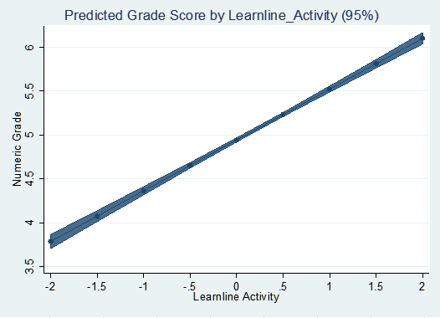

(b) Collaborate Participation and Numeric Grade for Unit
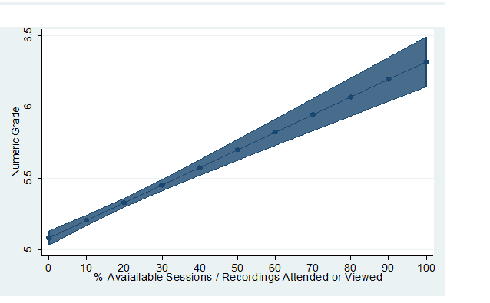
For Learnline Activity on average, those students who had the very lowest level of activity achieved a grade of just under a Pass score. In contrast, those who engaged the most achieved an average grade of Distinction (Figure 3.10). There is also a strong linear relationship between the use of Collaborate tools and the numerical grade awarded for the unit (Fig. 3.11), with a difference of about one and half grades in favour of the Collaborate sample for those who the most compared with the lowest average scoring group (albeit with a wider confidence interval).
Although these contrasted gains between the extremes of grouped values must be qualified by averaged effects between higher vs lower online activity groups samples as a whole, these are still are highly statistically significant, with the average marginal gain of about half a grade for increased Learnline Activity and about a third of a grade for increased Collaborate activity (see Table 1, accompanying paper).
The results of this minimal (“i.e. bivariate /unadjusted” for confounders”) model gives evidence of a significant and substantial marginal gain in grade awarded for in both Learnline and Collaborate samples. The Collaborate sample is smaller and its explanatory value lower than for Learnline Activity (4% against 10% of the variance explained in Numerical Grade Awarded). The lower value for the Collaborate sample is probably due to a restriction in range effect, as it included only those observations who had self-selected (volunteered) to participate in the range of trials of this innovative learning management tool.
However, In order to attribute any causal effect to online activity, the following sections will adjust these gains for the effects of student background and situation, as well as the take into account the possible influence of those factors which were neither observed nor included in our regression modelling.
Controlling for Pedagogic Context and Student Background Multivariate Regression with Marginsplots
A similar analytical method was then applied, introducing controls for possible “confounders”, all four pedagogic context categories together with a range of student background attributes. This was carried out for both the dichotomised and the continuous measures of treatment, again using multivariate OLS regression model (again Stata regress with robust option). The results for the binary treatment model are summarised in (Table 2 and for the continuous measurement in Figs. 3(a) & 3(b).
The following analyses will therefore subject this “zero order” explanatory effect of online Activity / Participation to the following questions: (a) will the “gap” between the “treated” and the “untreated” groups persist after a range of “confounders” have been controlled?; (b) will any effect be spread evenly across all four pedagogic contexts (mode of attendance and type of first year unit (Common or “Core”)? (c) what would be the effect should it be possible to simulate the conditions of random assignment to treatment of a properly conducted controlled experiment?
This stage continues to apply classical regression analysis techniques (Stata Ordinary Least Squares with a robust option) for arriving at the “best unbiased linear estimates” of the effect of treatments, context and covariate ”confounders”. In parallel with the previous strategy for and, “treatment” is defined in a binary variable (higher vs lower levels of online Activity/participation, as in Table (1) and then in more precise terms, as the continuous composite variables as used in Figs. 2(a) and 2(b).
Table 2. Predicted Numerical Grade Scores by Online Activity Group and Activity Type
(Controlling for Pedagogic Context and Selected Student Background Attributes)

 |  | Margin |  | Std. Err. | t | P>t | [95% Conf. | Interval]
Learnline Activity
Lower Activity ("Untreated") |  | 4.738 |  | 0.018 | 258.160 | 0.000 | 4.702 | 4.774
Higher Activity ("Treated") |  | 5.230 |  | 0.012 | 422.780 | 0.000 | 5.206 | 5.254
Higher vs Lower Activity (1 vs 0) |  | 0.492 |  | 0.022 |  |  | 0.448 | 0.536
Collaborate Participation |  | Margin |  | Std. Err. | t | P>t | [95% Conf. | Interval]
Lower Participation ("Untreated") |  |  | 5.103 | 0.031 | 162.140 | 0.000 | 5.041 | 5.165
Higher Participation ("Treated") | 5.360 |  |  | 0.018 | 295.980 | 0.000 | 5.325 | 5.396
Higher vs Lower Participation (1 vs0) | 0.257 |  |  | 0.037 |  |  | 0.186 | 0.329
A visual representation of continuous rather than the binary measurement of treatment effect (with controls for both contexts and covariates displayed below in marginsplot format. The effect of the composite measure of Learnline is shown in Fig.3(a), followed by that for Collaborate Participation Fig.3(b). The tabulated output for these regressions are available in Tables A.4and A.5 of the Technical Appendix).
Fig. 3 (a) Marginsplot of Grade Scale on Learnline Activity, Covariates and Pedagogic Context
(n=8,970; R2 adj. = .23)
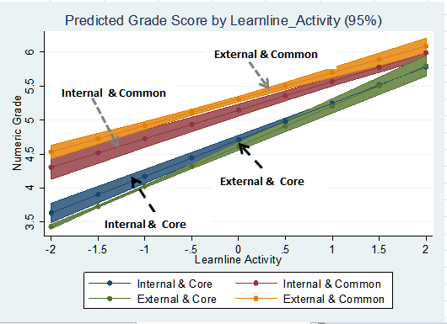
Fig. 3(b) Marginsplot of Grade Scale on Collaborate Activity, Covariates Context Terms*
(n=3,898; R2 adj. = .17)
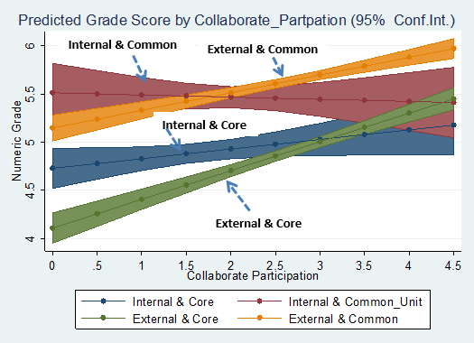

When compared with results for the previous simple bivariate regression, these tables and charts show that the addition of the contextual and covariate controls has produced:
- A pronounced increase in overall variance explained,from about 10% to 22% for the Learnline sample and an fourfold increase from about 4% to 17% for Collaborate (Appendix Tables A4 & A5);
- A slight decrease in the marginal effect of for Learnline Activity (from .6 to .49 for and from .34 to .26 for Collaborate Participation (Table 2 above);
- Relative stability in the predicted Numerical Grade Awarded, particularly for the “higher activty/Participation” groups (cf Table 1 and Table 2 above), where expected average appear to hit a “ceiling” of a mid-Credit level; and
- Evidence of heterogeneity in online Activity/Participation effect between Learnline and for Collaborate samples. Whereas the patterns for Learnline tend to cluster within Type of Unit and all four trajectories, those for Collaborate, show much lower gains (and perhaps a slight decline especially internal attendance sample for the “Internal and Common” subsample.
Despite these clear differences in the pattern of the context-based slopes for each, there is overwhelming evidence,even after adjustment for a range of student background attributes, of the positive effect of both types of increases in online Activity on the numeric grade awarded.
Summary: Regression Analysis
As for the simpler, unadjusted results in Fig. 2, the higher levels of online activity or participation show a consistent pattern of significant marginal gains in student success as indexed by increases (“gains”) in an expectation of awarded grades. Further interpretation of these differences, within and between the marginal plots merits further investigation, since the estimated effects are no doubt subject to variation in levels of exposure across unit types, promotion and integration of online learning within modes of delivery and assessment. It now remains to explore the possibility that these gains are largely due to the effect of unobserved factors which depend on the association of student propensity to engage online with those traits or dispositions that predict higher levels of academic performance. Unless these hidden effects can be detected and corrected, any attribution of causal effect on online engagement would rest on untested assumptions.

2. Correcting for Endogenous Treatment Bias: From Correlation to Causality
Before we may draw any causal inference from these results, we must be able to take into account hidden sources of bias due to the presence of unmeasured, “non-ignorable” confounders. Without testing for the endogenous effects of the unobserved “confounders” , we are in danger of producing unreliable and inconsistent findings, since these factors may at the same time be associated (either negatively or positively) with both levels of participation in online activity and with academic aptitude and commitment. In technical terms, these unobserved variables can produce what is known as “endogenous treatment” effects, those that appear to be embedded within, rather than external to, the predictive model set out in Fig. 1.
What, then, are the available means for detecting and correcting for biases due to the effect of both unobserved, as well as observed and measured, “confounders”?
(a) Exploring the counterfactual framework. Fortunately, recent statistical methods (such as the counterfactual framework, sometimes called the potential outcomes model) are available that allow the analyst to estimate, and correct for ,this source of bias by simulating the conditions of random assignment to levels of Activity.
Since in this study a random assignment of students to treatment conditions is either unfeasible or undesirable, the counterfactual model goes beyond the traditional regression questioning of the regression techniques reported above, to ask the more precise question that permits greater confidence in making causal inferences. Since the range of covariates that we have observed is limited to those available in official data records , before any causal conclusions are drawn, we should therefore control for the possible effects a host of unmeasured confounders that may be influencing the observed relationship between levels of online Activity and student success measured by Grade Awarded.
The counterfactual framework employs ‘switching’ methods to estimate what might happen if the probabilities of student success for the ‘untreated’’(or low Activity) group were applied to the outcome for the “treated” group. As Morgan and Winship (2015, pp. 13-14) explain:
For example, rather than ask the question: Does obtaining a college degree increase an individual’s labor market earnings?, the counterfactual model encourages the researchers to ask two questions:
- If high school graduates had instead obtained college degrees, how much would there labour market earnings have changed?
- If college graduates had only obtained high school diplomas, how much would their labour market earnings have changed?
This ‘switching’ provides two potential or counterfactual means for each treatment group, treated and untreated. The difference between these two potential means is called the Average Treatment effect (ATE). In this case, if we replace “earnings” with “grades”, “high school graduates” with “low onine Activity/ participating groups” and “college degrees” with “high online activity groups”, then it shouild be possible to use this framework to strip away the hidden factors in the regression model that predispose those students who are already well-positioned academically to be more active in online learning. By the same token, depending on the sign (positive or negative) of the relationship between these two types of influence, the degree and direction of these hidden factors may be more precisely identified and explored.
The counterfactual model will be executed by the etregress command (Stata 14 Treatment Effects Manual pp. 36-63). This is a linear endogenous treatment regression model estimated by Maximum Likelihood (ML) method, employing a binary treatment variable for online activity/ participation scored 0 and 1 as above for “untreated: and “treated” subsamples for both online types. As for the regression analyses reported in Tables 1 and 2, the cutoff point for the “untreated” group was set at zero or below for the log-transformed composite Learnline Activity measure and the bottom quartile of Collaborate Participation distribution (log transform of percentage of available sessions attended). In this analysis we will be also using the margins command to the full average treatment effect, allowing for interaction between treatment and the the four pedagogic contexts (Stata 14 Treatment Effects Manual, p. 42).
The frequency for both treatment groups is shown in the Table 3, with further breakdown by pedagogic context frequencies available in Tables B.1 and B.2 in the Technical Appendix.
Table 3 Treatment Groups for Learnline Activity and Collaborate Participation
Selection Groups | Learnline Activity |  | Collaborate Participation
 | Freq. | Percent | Freq. | Percent
"Untreated" | 3,018 | 33.48 | 1,075 | 27.53
"Treated" | 5,997 | 66.52 | 2,830 | 72.47
Total | 9,015 | 100 | 3,905 | 100

An endogenous treatment model (etregress command in Stata 14) was employed to estimate the average gain or difference between the potential mean grade awarded of the “treated” and the “untreated’ “ groups for both Learnline and Collaborate samples controlling for the range of pedatogic and individual student background variables and allowing for interactions between treatment condition and each of the four pedagogic contexts.
These results (Tables A.6and A.7 of the Technical Appendix) showed a vary good fit (p<.0001 in both cases), of the treatment effect model for the online binary treatment variable with high negative values of “rho1” for the treatment groups both samples Learnline= -0.62’ ; Collaborate = -.0.71). Error bars representing the means and confidence intervals (95%) the Average Treatment Effect (the difference between the two marginal potential means for of online Activity/Participation) were derived from these results and are displayed below (Fig. 4).

Fig. 4 Potential Average Numeric Grade Gains by Online Activity and Pedagogic Context
Error Bars (95% C.I.) based on Appendix Tables A.6 & A.7)
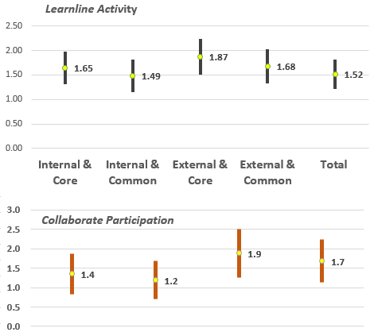
The error bars of Figure 4 indicate that the estimated average gains in potential means for higher Activity groups are all highly statistically significant for all contexts, with average improvement of about one and a half full grades across the four contexts of delivery. Although the error bar estimates tend to overlap statistically, the highest standout gains are for external enrolment observations, with the Internal and Core showing the lowest.
The improvement in gains for online Activity/Participation yielded by the counterfactual model over that recorded the OLS multiple (about one full awarded grade) is matched by a loss of predictive power of the full regression model for grade scores reported in Table 2. For Learnline sample, this represents a drop from 20.7% of variance explained for the OLS method to 15.4% for the counterfactual model, and from 15.25% to 6.8% for the Collaborate sample. This drop is explainable as the hidden endogenous bias that distorts the potential effect of the treatment are corrected and accompanied by gain in causal terms by the very large increases in the potential outcomes of about a whole numerical grade (see Fig. 5 below).
Except at the extremes of online Activity, these gains are much higher, by factor of three, than average estimated by the two ordinary regression models in section 1, whether bivariate and multivariate. The gains are also relatively evenly distributed across the four pedagogic contexts, though with consistently higher gains for External Mode and Collaborate Participation samples over those for Internal Mode and Learnline Activity - a not-unexpected result, given the restricted range of the self-selected (volunteered) Collaborate sample.

3. Interpreting the Counterfactual Model: from Causal Inference to Educational Practice
Why are these potential gains in grade scores across the units so much higher (by about one numeric grade) than those predicted by standard regression modelling, even after adjustment has been made for contexts and student background (i.e. in Tables 1 and 2)?
The answer to this question will involve: (a) comparing the size and incidence of predicted grades across the both samples and three regression models (bivariate, multivariate, counterfactual); (b) drawing any causal inferences that these descriptions may have online Activity/Participation for program development and course delivery.
- How do the patterns of gain in numerical grades predicted for each treatment group differ across the three regression approaches (bivariate, multivariate, counterfactual)?
For descriptive purposes, this subsection compares the means and variances predicted by the main estimation regimes. First, comparison of the three regression method shows both the size and the incidence of the online Activity/Participation “treatment” effect on the average or mean predicted grades for the respective first year units assessed (Fig. 5, based on Appendix Table A.8).
Fig. 5 Comparison of Predicted Numerical Gains in Grade Awarded: Three Regression Models
“Untreated” (left-hand scoreline) vs “Treated” (right-hand scoreline)
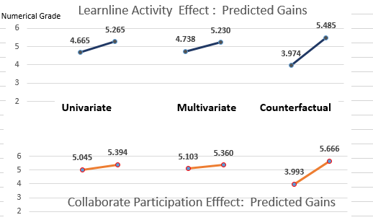
The most salient feature of the the scorelines of Fig. 5 is the far greater average gain in predicted grade scores (about one and a half grades) for the counterfactual method as against the two regression methods (between a third and a half a numerical grade) . In both samples, the increase for the “treated” (or higher Activity/Participation groups of about a quarter to a third of a grade improvement is overwhelmed by the deteriorating prospects of about one full grade for the “untreated” (or lower Activity/Participation).
The difference in predicted average or potential scores by multivariate regression and those by counterfactual model is illustrated in the histograms comparing their respective distributions. Fig. 6 displays a comparison of the histograms of predicted grade scores by both predictive models (multiple regression vs counterfactual or endogenous treatment) demonstrates the radically different patterns of distribution between “untreated” and the “treated” groups.
Fig. 6 Comparison of Distributions of Predicted Numerical Grade Scores*: Learnline and Collaborate
 | Multivariate Regression | Endogenous Treatment/ Counterfactual
Learnline | 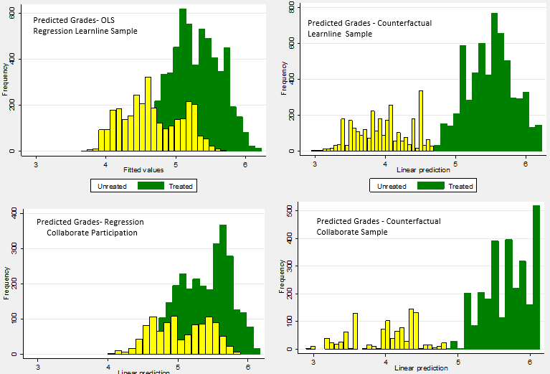
Collaborate
(Untreated = Yellow; Treated = Green

Whereas the predicted grades for the “untreated” tend to cluster within a single (though negatively skewed) distribution, the histograms of the counterfactual scores for both Learnline and Collaborate samples reveals an underlying bimodality that is only partially detected or largely obscured. Unless correction is made through experimental design or, as here, by counterfactual estimation techniques, these deeper divisions in the patterns of first year achievement would remain invisible and the opportunity for informed remedial action severely restricted.
- What are the implications of this interpretation for research directions and educational practice?
The directions for future research and educational practice for online learning are implied in finding from the counterfactual modelling of this section:
If the research into of the effects of online Activity on awarded grades were to be conducted as a controlled experiment where students were randomly assigned to either higher (“treated”) or lower (“untreated”) levels of Activity/ Participation, then it is likely that the grades of the ‘treated’ group would be only marginally higher, while those in the “untreated” group would be considerably lower.
Research into online effects might focus on the drivers of potential losses, rather than of potential gains, in academic outcomes. This insight would therefore appear to turn the original research question on its head. Rather than enquiring: “Who would benefit most from higher levels of online Activity?”, a more productive question for educational research might well be : “Who is most at risk of poorer outcomes due to lower rates of online Activity and how can these students be identified and more productively engaged?”

Summary and Conclusions
The value of the counterfactual framework does not appear not depend primarily in maximising the predictive value (e.g. “effect size”) of a treatment on a given sample. To the contrary, the findings indicate a more productive strategy that can detect, isolate and address those unobserved factors or “non-ignorable confounders” that either inhibit or enhance a propensity for online activity and participation. These results demonstrate that, without controlling for the disproportionate tendency in student populations of those do well academically to also be more active online, the correlational/ regression method will both underestimate the size of online treatment effects and guide research activity into less productive directions.
These findings may also help to define the limitations of educational policy and practice, since universities by themselves cannot manipulate the wider sociological and cultural forces that lie behind the processes of self-selection to treatment. Education, as it is often said, “cannot compensate for society”. The objective of research should therefore be to identify and address those which can be manipulated by program development and delivery that remove or address the sources of “blockage” to online Activity or Participation.
In sum, the research problem seems to be one of detecting and overcoming the unobserved deterrents to higher levels of Activity, rather than encouraging those who already have a prior disposition to engage to gain a marginal advantage. A tendency of “preaching to the converted” by general exhortations or inducements would seem not be not nearly as productive, then, as a targeted approach that paid attention to the unobserved factors defining those divisions in the first year student population that are often disguised in purely correlational findings.
Suggested Directions for further research: The positive and encouraging results of this analysis recommend further exploration of the causal effects of online engagement as a moderating and mediating student background, notably:
- Identification of the source, structure and significance of the unmeasured influences that apparently exert a suppression effect on online learning and its positive effect on potential grades.
- Inclusion of non-participating groups (esp. for Collaborate) in the evaluation samples, together with more precise description of the individual activity items accessed for Learnline.
- Exploration of non-linear and non-additive effects of online Activity, as well as of covariate and ‘treatment interactions.
- Extensions of the present counterfactual model to include other forms of student engagement, especially with learning-related systems, such as support and library services.
- Estimation of the effects of online and ethically-approved social media for community-building from both course-related and informal networking.
The task ahead, therefore, is to identify the source of the effect of those “confounders” that reduce the potentially beneficial effects of access to online Activity and Participation. In light of the finding that motivational factors do not appear to be playing a significant part, further exploration of this “undiscovered territory” might yield important insights into strategies of for more effective pedagogic and managerial intervention. It is in this area that the qualitative findings from focus groups and survey research have an important role to play, in detecting those factors surrounding social, cultural and linguistic backgrounds situations of first year student, their technological readiness and interface with work, family and leisure that inhibit or enhance the quality of their interaction with online learning media.

Bibliography
Burke, L 2017 ‘Nation of dropouts: University completion rates drop to a new low’,
https://www.news.com.au/finance/work/careers/nation-of-dropouts-university-completion-rates-drop-to-a-new-low/news-story/1265f4d9872db263694aaa74f815c432
Bradley, D 2008, Review of Australian Higher Education: Final Report, Commonwealth of Australia, Commonwealth Department of Education, Employment and Work Relations http://www.deewr.gov.au/HigherEducation/Review/Documents/PDF/Higher%20Education%20Review_one%20document_02.pdf
Brame, CJ 2013 *Flipping the classroom, Vanderbilt University Center for Teaching,
http://cft.vanderbilt.edu/guides-sub-pages/flipping-the-classroom/
Corbyn, Z 2012, ‘Hype, hope or harbinger of doom?’, Times Higher Education Supplement, 6th December.
Davies, M 2012, ‘Can Universities Survive the Digital Revolution’ Quadrant, vol.56, no. 12, pp. 58-66.
Department of Education, Employment and Work Relations (Commonwealth Government) 2012, ‘Higher Education’, in Year Book Australia, 2012, 1301.0, Australian Bureau of Statistics, Canberra.
Department of Education and Training (Commonwealth Government) 2017, Completion Rates of Higher Education Students - Cohort Analysis, 2005-2014.
Ernst & Young 2012, University of the Future: a Thousand Year Institution on the Cusp of Profound Change, http://www.ey.com/Publication/vwLUAssets/University_of_the_future/$FILE/University_of_the_future_2012.pdf
Guo, S & Fraser, MW 2015, Propensity Score Analysis: Statistical Methods and Applications, Advanced Quantitative Techniques in the Social Sciences Series (11), Sage.
James, R 2012, ‘Brace for the Dawn of Digital Delivery’, The Australian Higher Education Supplement, 24th October.
Moodie, G 2010 ‘Trends and Opportunities in Australian Higher Education Post 2012’, University of New England Council Retreat, Bundarra, New South Wales, http://www.une.edu.au/governance/academicboard/Occasional%20Addresses/gavin-moodie.pdf
Morgan, SL & Winship, C 2015, Counterfactuals and Causal Inference: Methods and Principles for Social Research, 2nd edn., Cambridge University Press, New York.
Nelson, K 2015, ‘Using K-Means Clustering to Model Students’ LMS Participation in Traditional Courses’, Issues in Information Systems, vol. 16, no. 4, pp. 102-110.
Oblinger, DG, Barone, CA, Hawkins, BI 2001, Distributed Learning: Challenges, Choices and a New Environment, Educause Series, D.C. American Council on Education, Washington.
Organisation for Economic Co-operation and Development 2005, The Measurement of Scientific and Technological Activities: Guidelines for Collecting and Interpreting Innovation Data, Oslo Manual, 3rd edn., Working Party of National Experts on Scientific and Technology Indicators, OECD, Paris, http://stats.oecd.org/glossary/detail.asp?ID=6864
Piccoli, G, Rami, A & Blake, I 2001, ‘Web-based Virtual Learning Environments: A research framework and a preliminary assessment of effectiveness in basic IT skills training’. Management Information Systems Quarterly, vol. 25, no. 4, pp. 401-406.
Stata Corporation 2014, Stata Treatment Effects Reference Manual: Potential Outcomes/ Counterfactual Outcomes, Release 14, College Station, Stata Corporation, Texas
https://www.stata.com/manuals14/te.pdf
Tyler, W, Rolls, N, Bridgeman, S & Flack, M 2011, The Common Units: Equity, Achievement and Retention: an Innovative First Year University Program in Review, Report prepared for the Common Unit Management Group, School of Academic Language and Learning, Charles Darwin University.
Tyler, W & Rolls, N 2016, ‘Caught in the net?: Innovation and performativity in an Australian university program’ in Vitale, P. & Exley, B (eds), Pedagogic Rights and Democratic Education, Routledge.
Tyler-Smith, K 2006, ‘Early Attrition among First Time eLearners: A Review of Factors that Contribute to Drop-out, Withdrawal and Non-completion Rates of Adult Learners undertaking eLearning Programmes’, Journal of Online Learning and Teaching,
http://jolt.merlot.org/vol2no2/tyler-smith.
Wooldridge, J. M. (2010). Econometric Analysis of Cross Section and Panel Data, 2nd edn., MIT Press.

Technical Appendices: A. Regression (OLS) and Counterfactual Analysis Output
B. Descriptives of Treated and Untreated Groups
Table A.1 Detailed Results of Bivariate Regression for Binary Activity/Participation Treatment Groups
(see Table 1 of Text)
Activity Sample | Learnline | Collaborate
Number of obs | 9015 | 3905
F(1, 9013) | 700.53 | 85.93
Prob > F | 0 | 0
R-squared | 0.0721 | 0.0232
Adj R-squared | 0.072
Root MSE | 1.0154 | 1.0128

Table A.2 Detailed Resultes of Bivariate Regression for Continous Activity/Participation Treatment
(see Table 2 and Figs. 2(a) & 2(b) of Text)
 | Learnline | Collaborate
Number of obs | 8,991 | 3,905
F(1, 8989) | 1031.37 | 160.15
Prob > F | 0 | 0
R-squared | 0.105 | 0.0418
Root MSE | 0.99706 | 1.0031

Table A.3 Results of Regression for Continuous Activity/Participation Marginsplot
(see Table 2 and Figs. 2(a) & 2(b) of Text)
Grade_Scale | Coef. | Std. Err. | t | P>t | [95% Conf. | Interval]
Learnline Activity | 0.579 | 0.018 | 32.110 | 0.000 | 0.544 | 0.615
_cons | 4.944 | 0.011 | 434.180 | 0.000 | 4.921 | 4.966
Collaborate Participation | 0.225 | 0.018 | 12.660 | 0.000 | 0.190 | 0.260
_cons | 4.739 | 0.048 | 98.240 | 0.000 | 4.645 | 4.834

Table A.4

Results of OLS Regression of Grade Awarded on Learnline Activity (Continuous Treatment)
Pedagogic Context & Student Characteristics
Source | SS | df | MS | Number of obs | = | 8970.000
 |  |  |  | F(17, 8952) | = | 154.040
Model | 2251.363 | 17.000 | 132.433 | Prob > F | = | 0.000
Residual | 7696.503 | 8952.000 | 0.860 | R-squared | = | 0.226
 |  |  |  | Adj R-squared | = | 0.225
Total | 9947.866 | 8969.000 | 1.109 | Root MSE | = | 0.927
GradeScale | Coef. | Std. Err. |  | t | P>t | 95% Conf.Int.
Commonn by Mode
Internal & Commonn | 0.438 | 0.031 | 14.040 | 0.000 | 0.377 | 0.499
External & Core | -0.093 | 0.033 | -2.810 | 0.005 | -0.159 | -0.028
External & Commonn | 0.601 | 0.032 | 18.770 | 0.000 | 0.538 | 0.664
Learnline Activity | 0.538 | 0.036 | 14.920 | 0.000 | 0.467 | 0.608
Commonn_mode#c.Learnline_Activity
Internal & Commonn | -0.117 | 0.059 | -1.980 | 0.048 | -0.233 | -0.001
External & Core | 0.055 | 0.048 | 1.140 | 0.253 | -0.039 | 0.148
External & Commonn | -0.148 | 0.047 | -3.150 | 0.002 | -0.239 | -0.056
Age | 0.008 | 0.001 | 5.970 | 0.000 | 0.005 | 0.010
Male | -0.137 | 0.022 | -6.220 | 0.000 | -0.180 | -0.094
Indigenous | -0.275 | 0.049 | -5.660 | 0.000 | -0.371 | -0.180
NESB | -0.291 | 0.028 | -10.220 | 0.000 | -0.346 | -0.235
BOA_HE_Course | 0.053 | 0.044 | 1.200 | 0.229 | -0.034 | 0.141
BOA_Mature_Age_Entry | -0.197 | 0.051 | -3.870 | 0.000 | -0.297 | -0.097
BOA_Prof_Qual | -0.218 | 0.057 | -3.840 | 0.000 | -0.330 | -0.107
BOA_Sec_Educ | -0.067 | 0.045 | -1.490 | 0.137 | -0.155 | 0.021
BOA_TAFE_Award | -0.129 | 0.049 | -2.630 | 0.008 | -0.225 | -0.033
TER_Present | 0.243 | 0.025 | 9.740 | 0.000 | 0.194 | 0.291
_cons | 4.571 | 0.058 | 79.470 | 0.000 | 4.458 | 4.684

Table A.5 Results of OLS Regression: Collaborate Participation by Pedagogic Context & Student Background
Source | SS | df | MS | Number of obs | = | 3898.000
 |  |  |  | F(17, 3880) | = | 47.350
Model | 702.388 | 17.000 | 41.317 | Prob > F | = | 0.000
Residual | 3385.631 | 3880.000 | 0.873 | R-squared | = | 0.172
 |  |  |  | Adj R-squared | = | 0.168
Total | 4088.020 | 3897.000 | 1.049 | Root MSE | = | 0.934
Grade_Scale | Coef. | Std. Err. | t | P>t | [95% Conf. Interval)
Commonn_mode
Internal & Commonn_Unit | 0.783 | 0.186 | 4.220 | 0.000 | 0.419 | 1.146
External & Core | -0.619 | 0.132 | -4.670 | 0.000 | -0.878 | -0.359
External & Commonn | 0.418 | 0.125 | 3.340 | 0.001 | 0.173 | 0.664
Collaborate_Participation | 0.100 | 0.054 | 1.840 | 0.067 | -0.007 | 0.206
Commonn_mode#c.Collaborate_Participation
Internal & Commonn_Unit | -0.122 | 0.090 | -1.360 | 0.174 | -0.299 | 0.054
External & Core | 0.198 | 0.061 | 3.230 | 0.001 | 0.078 | 0.318
External & Commonn | 0.083 | 0.060 | 1.390 | 0.164 | -0.034 | 0.200
Age | 0.005 | 0.002 | 2.960 | 0.003 | 0.002 | 0.008
Male | -0.071 | 0.036 | -1.960 | 0.050 | -0.142 | 0.000
Indigenous | -0.322 | 0.079 | -4.100 | 0.000 | -0.476 | -0.168
NESB | -0.237 | 0.049 | -4.800 | 0.000 | -0.334 | -0.140
BOA_HE_Course | 0.099 | 0.070 | 1.410 | 0.159 | -0.039 | 0.236
BOA_Mature_Age_Entry | -0.218 | 0.075 | -2.910 | 0.004 | -0.365 | -0.071
BOA_Professional_Qual | -0.259 | 0.080 | -3.230 | 0.001 | -0.416 | -0.102
BOA_SEC_Education | -0.077 | 0.072 | -1.070 | 0.286 | -0.219 | 0.065
BOA_TAFE_Award | -0.177 | 0.073 | -2.420 | 0.015 | -0.320 | -0.034
TER_Present | 0.157 | 0.036 | 4.390 | 0.000 | 0.087 | 0.227

Table A.6 Results of Endogenous Treatment Regression Model – Learnline Activity
 | inear regression with endogenous treatment | Number of obs | = | 8994.000
 | Estimator: maximum likelihood | Wald chi2(15) | = | 1545.690
 | Log pseudolikelihood = -17514.715 | Prob > chi2 | = | 0.000
 |  | Robust
 | Coef. | Std. Err. | z | P>z | [95% Conf. | Interval]
GradeScale
Commonn_mode
Internal & Commonn | 0.3917892 | 0.059 | 6.660 | 0.000 | 0.276 | 0.507
External & Core | -0.2993897 | 0.063 | -4.790 | 0.000 | -0.422 | -0.177
External & Commonn | 0.3767281 | 0.065 | 5.820 | 0.000 | 0.250 | 0.504
1.Learnline_dich | 1.442858 | 0.152 | 9.480 | 0.000 | 1.145 | 1.741
Commonn_mode#Learnline_dich
Internal & Commonn#1 | -0.1196485 | 0.070 | -1.700 | 0.089 | -0.257 | 0.018
External & Core#1 | 0.2539173 | 0.073 | 3.500 | 0.000 | 0.112 | 0.396
External & Commonn#1 | 0.0897175 | 0.077 | 1.170 | 0.242 | -0.061 | 0.240
Age | 0.0021864 | 0.002 | 1.210 | 0.227 | -0.001 | 0.006
Male | -0.0942346 | 0.025 | -3.710 | 0.000 | -0.144 | -0.044
Indigenous | -0.213088 | 0.059 | -3.620 | 0.000 | -0.328 | -0.098
NESB | -0.2964868 | 0.031 | -9.470 | 0.000 | -0.358 | -0.235
BOA_HE_Course | 0.136218 | 0.027 | 5.010 | 0.000 | 0.083 | 0.190
BOA_Mature_Age_Entry | -0.1217863 | 0.039 | -3.110 | 0.002 | -0.199 | -0.045
BOA_TAFE_Award | -0.0941398 | 0.036 | -2.650 | 0.008 | -0.164 | -0.024
TER_Present | 0.3205332 | 0.028 | 11.410 | 0.000 | 0.265 | 0.376
_cons | 3.741744 | 0.096 | 38.970 | 0.000 | 3.554 | 3.930
Learnline_dich
Commonn_mode
Internal & Commonn | 0.3929841 | 0.042 | 9.330 | 0.000 | 0.310 | 0.476
External & Core | 0.2357895 | 0.047 | 5.040 | 0.000 | 0.144 | 0.328
External & Commonn | 0.4695063 | 0.046 | 10.170 | 0.000 | 0.379 | 0.560
Age | 0.0272352 | 0.002 | 13.130 | 0.000 | 0.023 | 0.031
Male | -0.1685854 | 0.030 | -5.560 | 0.000 | -0.228 | -0.109
Indigenous | -0.3640985 | 0.072 | -5.030 | 0.000 | -0.506 | -0.222
NESB | 0.004745 | 0.040 | 0.120 | 0.906 | -0.074 | 0.083
BOA_HE_Course | -0.0311367 | 0.036 | -0.850 | 0.393 | -0.103 | 0.040
BOA_Mature_Age_Entry | 0.0729737 | 0.056 | 1.310 | 0.192 | -0.037 | 0.182
BOA_Prof_Qual | -0.1186257 | 0.060 | -1.960 | 0.049 | -0.237 | 0.000
BOA_TAFE_Award | 0.2121092 | 0.052 | 4.080 | 0.000 | 0.110 | 0.314
BOA_Other | 0.2285723 | 0.097 | 2.360 | 0.018 | 0.039 | 0.418
TER_Present | -0.2273225 | 0.034 | -6.610 | 0.000 | -0.295 | -0.160
_cons | -0.471563 | 0.067 | -7.020 | 0.000 | -0.603 | -0.340
/athrho0 | -0.7270406 | 0.118 | -6.150 | 0.000 | -0.959 | -0.495
/lnsigma0 | 0.1185469 | 0.0426331 | 2.78 | 0.005 | 0.0349875 | 0.2021063
/athrho1 | -0.5056526 | 0.1142754 | -4.42 | 0 | -0.7296284 | -0.2816769
/lnsigma1 | -0.0215051 | 0.0253425 | -0.85 | 0.396 | -0.0711754 | 0.0281653
rho0 | -0.6212515 | 0.0726007 |  |  | -0.7437293 | -0.4584189
sigma0 | 1.12586 | 0.0479989 |  |  | 1.035607 | 1.223978
lambda0 | -0.699442 | 0.1107378 |  |  | -0.9164841 | -0.4823999
rho1 | -0.466551 | 0.0894011 |  |  | -0.622838 | -0.2744564
sigma1 | 0.9787245 | 0.0248033 |  |  | 0.9312985 | 1.028566
lambda1 | -0.4566249 | 0.0985025 |  |  | -0.6496863 | -0.2635635
Wald test of indep. (rho0 = rho1 = 0): chi2(2) = 43.07 Prob > chi2 = 0.0000

Table A. 7 Results of Endogenous Treatment Regression Model – Collaborate Participation
 |  | Robust
 | Coef. | Std. Err. | z | P>z | [95% Conf. | Interval]
Grade_Scale
Commonn_mode
Internal & Commonn_Unit | 0.388 | 0.131 | 2.960 | 0.003 | 0.132 | 0.645
External & Core | -0.851 | 0.180 | -4.730 | 0.000 | -1.204 | -0.499
External & Commonn | -0.045 | 0.166 | -0.270 | 0.786 | -0.371 | 0.281
Collaborate Participation | 1.354 | 0.268 | 5.050 | 0.000 | 0.828 | 1.879
Commonn_mode#collab_dich
Internal & Commonn_Unit#1 | -0.164 | 0.175 | -0.940 | 0.347 | -0.507 | 0.178
External & Core#1 | 0.527 | 0.216 | 2.440 | 0.015 | 0.104 | 0.951
External & Commonn#1 | 0.329 | 0.239 | 1.370 | 0.169 | -0.140 | 0.797
Age | 0.001 | 0.002 | 0.360 | 0.718 | -0.004 | 0.005
Male | -0.005 | 0.044 | -0.120 | 0.904 | -0.092 | 0.082
Indigenous | -0.201 | 0.106 | -1.900 | 0.057 | -0.408 | 0.006
NESB | -0.241 | 0.062 | -3.870 | 0.000 | -0.363 | -0.119
BOA_HE_Course | 0.240 | 0.047 | 5.130 | 0.000 | 0.149 | 0.332
BOA_Mature_Age_Entry | -0.130 | 0.053 | -2.450 | 0.014 | -0.234 | -0.026
BOA_TAFE_Award | -0.087 | 0.049 | -1.800 | 0.073 | -0.183 | 0.008
TER_Present | 0.179 | 0.039 | 4.610 | 0.000 | 0.103 | 0.255
_cons | 4.160 | 0.178 | 23.350 | 0.000 | 3.811 | 4.510
Collaborate Participation - Binary
Commonn_mode
Internal & Commonn_Unit | 0.552 | 0.098 | 5.660 | 0.000 | 0.361 | 0.744
External & Core | 0.858 | 0.085 | 10.080 | 0.000 | 0.691 | 1.025
External & Commonn | 0.944 | 0.090 | 10.460 | 0.000 | 0.767 | 1.121
Age | 0.016 | 0.003 | 5.740 | 0.000 | 0.011 | 0.022
Male | -0.148 | 0.052 | -2.870 | 0.004 | -0.250 | -0.047
Indigenous | -0.333 | 0.112 | -2.980 | 0.003 | -0.552 | -0.114
NESB | -0.067 | 0.083 | -0.800 | 0.423 | -0.230 | 0.097
BOA_HE_Course | -0.125 | 0.061 | -2.050 | 0.040 | -0.245 | -0.006
BOA_Mature_Age_Entry | 0.037 | 0.073 | 0.500 | 0.618 | -0.107 | 0.180
BOA_Professional_Qual | -0.084 | 0.084 | -1.010 | 0.314 | -0.248 | 0.080
BOA_TAFE_Award | 0.049 | 0.071 | 0.690 | 0.488 | -0.090 | 0.188
BOA_Other_Basis | 0.084 | 0.144 | 0.580 | 0.559 | -0.198 | 0.366
TER_Present | -0.021 | 0.050 | -0.420 | 0.671 | -0.119 | 0.077
_cons | -0.582 | 0.109 | -5.340 | 0.000 | -0.796 | -0.369
/athrho0 | -0.894 | 0.219 | -4.080 | 0.000 | -1.324 | -0.464
/lnsigma0 | 0.232 | 0.086 | 2.710 | 0.007 | 0.064 | 0.400
/athrho1 | -0.762 | 0.246 | -3.100 | 0.002 | -1.244 | -0.280
/lnsigma1 | 0.018 | 0.056 | 0.330 | 0.744 | -0.091 | 0.128
rho0 | -0.713 | 0.108 |  |  | -0.868 | -0.433
sigma0 | 1.261 | 0.108 |  |  | 1.066 | 1.491
lambda0 | -0.900 | 0.211 |  |  | -1.314 | -0.485
rho1 | -0.642 | 0.144 |  |  | -0.847 | -0.273
sigma1 | 1.018 | 0.057 |  |  | 0.913 | 1.136
lambda1 | -0.654 | 0.183 |  |  | -1.013 | -0.296

Table A. 8 Summary Table of Online Activity/Participation Effects by Predictive Method:
Learnline and Collaborate Samples
Predictive Model & Activity Level | Margin | Std. Err. | z | P>z | [95% Conf. | Interval]
 |  | Learnline Activity Effect
Bivariate
Lower Activity ("Untreated") | 4.665 | 0.018 | 252.410 | 0.000 | 4.629 | 4.702
Higher Activity ("Treated") | 5.265 | 0.013 | 401.560 | 0.000 | 5.239 | 5.291
Multivariate
Lower Activity ("Untreated") | 4.738 | 0.019 | 251.800 | 0.000 | 4.701 | 4.775
Higher Activity ("Treated") | 5.230 | 0.013 | 401.590 | 0.000 | 5.204 | 5.255
Potential Means/ Counterfactual
Lower Activity ("Untreated") | 3.974 | 0.122 | 32.560 | 0.000 | 3.734 | 4.213
Higher Activity ("Treated") | 5.485 | 0.057 | 96.220 | 0.000 | 5.373 | 5.597
 |  | Collaborate Participation Effect
Bivariate
Lower Learnline Activity | 5.045 | 0.033 | 153.850 | 0.000 | 4.980 | 5.109
Higher Learnline Activity | 5.394 | 0.019 | 290.400 | 0.000 | 5.358 | 5.430
Multivariate
Lower Learnline Activity | 5.103 | 0.032 | 159.170 | 0.000 | 5.040 | 5.166
Higher Learnline Activity | 5.360 | 0.019 | 280.480 | 0.000 | 5.323 | 5.398
Potential Means/ Counterfactual
Lower Collaborate Participation | 3.993 | 0.265 | 15.100 | 0.000 | 3.475 | 4.511
Higher Collaborate Participation | 5.666 | 0.091 | 62.170 | 0.000 | 5.487 | 5.844

Appendix B. Tables B.1 & B.2
Table B.1 Learnline Sample: Crosstabulation of Grade Score by Treatment Score and Ped. Context
Treated Learnline Sample: Grade Score by Mode of Attendance and Unit Type
Commonn_mode | N | mean | sd | se | p50
Internal & Core | 1041.000 | 4.839 | 1.066 | 0.033 | 5.000
Internal & Common | 1180.000 | 5.203 | 0.919 | 0.027 | 5.000
External & Core | 1541.000 | 5.099 | 1.082 | 0.028 | 5.000
External & Common | 2235.000 | 5.611 | 0.803 | 0.017 | 6.000
Total | 5997.000 | 5.265 | 0.994 | 0.013 | 5.000
Untreated Learnline Sample : Grade Score by Mode of Attendance and Unit Type
Commonn_mode | N | mean | sd | se | p50
Internal & Core | 987.000 | 4.334 | 1.056 | 0.034 | 4.000
Internal & Commonn | 618.000 | 4.900 | 0.973 | 0.039 | 5.000
External & Core | 689.000 | 4.403 | 1.004 | 0.038 | 4.000
External & Commonn | 724.000 | 5.166 | 0.928 | 0.034 | 5.000
Total | 3018.000 | 4.665 | 1.057 | 0.019 | 5.000

Table B2.Collaborate Sample: Crosstab of Grade Score by Treatment Group and Pedagogic Context
Treated Collaborate Sample: Grade Score by Mode of Attendance and Unit Type
Commonn_mode | N | mean | sd | se(mean) | p50
Internal & Core | 163 | 4.933 | 1.055 | 0.083 | 5
Internal & Commonn | 192 | 5.328 | 0.961 | 0.069 | 5
External & Core | 971 | 5.059 | 1.103 | 0.035 | 5
External & Commonn | 1504 | 5.669 | 0.802 | 0.021 | 6
Total | 2830 | 5.394 | 0.988 | 0.019 | 6
Untreated Learnline Sample : Grade Score by Mode of Attendance and Unit Type
Commonn_mode | N | mean | sd | se(mean) | p50
Internal & Core | 250 | 4.816 | 1.164 | 0.074 | 5
Internal & Common | 130 | 5.408 | 0.912 | 0.080 | 6
External & Core | 312 | 4.641 | 1.122 | 0.064 | 4
External & Commonn | 383 | 5.399 | 0.850 | 0.043 | 6
Total | 1075 | 5.045 | 1.075 | 0.033 | 5

The negative values for Learnline for (Figs. 2(a); 3(a) below) were the result of the logarithmic transformation (base 10) of highly skewed distribution of the mean composite scores at each point on the x axis to the mean of the entire sample. The percentage Collaborate Participation were raw scores for the regressions (Figs. 2(b); 3(b) were log-transformed in the following section for comparison with counterfactual/potential outcomes).
The output for full regression models with continuous treatment measures is available in the Technical Appendix Tables A.4 and A.5).
Two Basis of Entry variables – “Professional Qualification” and “Other Basis” were defined as instrumental variable ie included in the treatment equation but omitted from the main (outcome) equation.
This statistic, whose value and sign indexes the correletion between the the unexplained variance (residuals) in the models predictive outcome and to online activity, is the measure of endogenous bias in the counterfactual model. It will be the subject of more detailed description and interpretation in future research.
Based on Appendix Table A.8
For tables shown in this Appendix the log-transformed values of Collaborate Participation (Percentage of available sessions viewed0 were used (see also footnote 1 in text)

